QNX ECU Watchdog Technical Report
QNX ECU WATCHDOG & RECOVERY

Real-Time Automotive ECU Fault Detection and Selective Recovery Framework

Technical Project Report

Team Name: QNX SENTINEL

Institution: Dhanekula Institute of Engineering and Technology

Team Members:
- Anumolu Mohini Sri
- Talari Krishna Kishore

Platform: QNX 8.0 | Raspberry Pi 4

Date of Evidence: October 2026

Contents
1. Cover page
2. Abstract
3. Problem statement
4. Project objectives
5. System overview
6. QNX architecture
7. ECU Process Architecture
8.Heartbeat Monitoring and Watchdog Mechanism
9. Inter-Process Communication (IPC)
10. Fault Detection and Fault Injection
11.Recovery Manager and Selective ECU Recovery
12.Priority Scheduling and Real-Time Operation
13.GPIO Hardware Integration
14. Performance evaluation
15.QNX System Monitoring and Analysis
16. Testing and validation
17. Results
18. Limitations
19. Future work
20. Conclusion
21. Appendix
How the evidence is used in this report
All measurements and test results presented in this report are based on the evidence collected during the development and testing of the ECU Watchdog & Recovery Framework on the QNX RTOS platform. The evidence includes terminal outputs, QNX process and system monitoring information, fault-injection results, recovery logs, and photographs or screenshots of the Raspberry Pi hardware integration.
The report distinguishes between the following types of statements:
- Observed: Values and system behaviour directly visible in terminal outputs, logs, screenshots, or hardware test evidence. These are reported as observed during testing.
- Design (source): Information describing how the system is implemented, including ECU processes, heartbeat intervals, watchdog logic, IPC mechanisms, priorities, timers, and recovery logic. These describe the design and are not treated as measured results.
- Test Results: Results obtained by intentionally injecting faults into individual ECU services and

observing fault detection, recovery initiation, and restoration of the affected service.
- Hardware Evidence: Evidence from the Raspberry Pi integration, including UART communication and GPIO-based ECU status indication using LEDs and the fault-injection button.
- Not Verified: Any value or behaviour for which sufficient test evidence is not available is explicitly marked as Not verified rather than being presented as a measured result.

2. Abstract
Modern automotive systems use multiple Electronic Control Units (ECUs) to perform different control and monitoring functions. A failure in one ECU service can interrupt its operation and may affect other services if recovery is not properly isolated. Restarting the complete system to recover a single failed service can also cause unnecessary disruption.
QNX Sentinel is a QNX-based ECU Watchdog and Recovery Framework developed to demonstrate heartbeat monitoring, fault detection, and selective recovery of individual ECU processes. The framework consists of three simulated ECU services: Engine ECU, Brake ECU, and Steering ECU. A fault-injection utility is provided to introduce selected failure conditions, including heartbeat suppression, a simulated deadlock, and an execution overrun.
The monitoring component identifies missing ECU heartbeats and initiates the recovery procedure for the affected service. Runtime terminal logs demonstrate Engine ECU heartbeat-failure detection and recovery activity, as well as Brake ECU deadlock-related detection and process restart. During the displayed recovery sequences, heartbeat messages from unaffected ECU services remain visible, providing evidence of continued activity.
The project uses QNX inter-process communication and process-management mechanisms to support monitoring and recovery. Raspberry Pi GPIO-based LED indicators are planned as a hardware status interface for representing ECU health, recovery, and failure states. Further timing measurements and hardware validation are required to establish complete recovery performance and verify all hardware functions.
The project demonstrates the practical application of process isolation, heartbeat-based fault detection, fault injection, and selective ECU recovery in a QNX environment.
3. Problem Statement
Modern automotive systems rely on multiple Electronic Control Units (ECUs) to perform independent control and monitoring functions. Each ECU service is expected to operate continuously and respond within its intended execution time. If an ECU service stops generating heartbeats or becomes unresponsive, the system must identify the affected service and respond appropriately.
A major challenge in ECU supervision is detecting service failures independently of process existence. A process may remain present in the system while its expected activity has stopped. Without continuous health monitoring, such failures may remain undetected until they affect subsequent operations.
Restarting the entire application or system to recover a single failed ECU service can unnecessarily interrupt other functioning services. Therefore, a recovery mechanism is required to identify the affected ECU process and isolate the recovery operation to that process while monitoring the remaining services.
The QNX Sentinel project addresses this problem by developing a QNX-based framework that monitors three simulated ECU services—Engine, Brake, and Steering—using heartbeat communication and a watchdog mechanism. A fault-injection utility introduces selected failure conditions to evaluate the monitoring and recovery behavior. When a failure is identified, the framework initiates recovery of the affected ECU process and checks for the restoration of its heartbeat.
The primary engineering problem is to demonstrate fault detection and selective process recovery while maintaining the activity of unaffected ECU services, and to evaluate this behavior using runtime logs and system-level testing.

4. Project Objectives
The primary objective of QNX Sentinel is to develop a QNX-based watchdog and recovery framework that monitors individual ECU services, identifies selected failure conditions, and supports selective recovery of the affected process.
The specific objectives are:
- Develop independent ECU processes: Implement separate Engine ECU, Brake ECU, and Steering ECU processes to represent independently operating automotive services.
- Implement heartbeat monitoring: Establish periodic heartbeat communication between the ECU processes and the monitoring component to track service activity.
- Develop a watchdog mechanism: Identify missing heartbeats and report suspected ECU failures based on the configured monitoring timeout.
- Implement fault injection: Provide a fault-injection utility to introduce Engine ECU heartbeat suppression, Brake ECU simulated deadlock, and Steering ECU execution overrun for testing purposes.
- Support selective ECU recovery: Restart the affected ECU process following fault detection without intentionally restarting all ECU services.
- Verify service restoration: Use heartbeat reception and runtime logs to check whether a restarted ECU resumes its expected monitored activity.
- Observe healthy-service continuity: Examine whether unaffected ECU services continue generating heartbeats during another ECU's recovery.
- Evaluate runtime behavior: Record fault-detection observations, recovery events, and timing information to assess the framework's behavior under the tested conditions.
- Support hardware status indication: Define GPIO-based LED status indication for the Engine, Brake, and Steering ECU services, subject to verification of the completed hardware integration.
5. System Overview
QNX Sentinel is a QNX-based Automotive ECU Watchdog and Recovery Framework designed to monitor three simulated ECU services: Engine ECU, Brake ECU, and Steering ECU. The framework uses independent ECU processes, heartbeat communication, fault injection, and process-level recovery to demonstrate fault detection and selective recovery.

5.1 Main System Components

The framework consists of the following components:
- Engine ECU: Simulates an engine-control service and periodically transmits heartbeat messages to indicate service activity. Its fault-injection handler can disable heartbeat transmission.
- Brake ECU: Simulates a brake-control service and periodically transmits heartbeat messages. It supports a simulated deadlock condition that blocks the main heartbeat-producing thread.
- Steering ECU: Simulates a steering-control task, generates heartbeat messages, and supports an injected execution delay for overrun testing.
- Health Monitor and Watchdog: Monitors ECU activity and identifies missing-heartbeat conditions. The exact timeout and recovery-decision logic is described in the corresponding watchdog section.
- Fault Injector: Provides a command-line interface for selecting and sending fault-injection requests to the ECU services.
- Recovery Manager and Supervisor: Manage the recovery of an affected ECU process. Their exact responsibilities and process-management mechanisms are documented in Section 11 based on the implementation.
- Status Logging: Terminal output records heartbeat activity, fault events, and recovery messages, providing evidence for runtime analysis.
- Raspberry Pi GPIO Interface: Provides the planned physical status indication through nine LEDs assigned to the Engine, Brake, and Steering ECU services.

5.2 Overall Operation
During normal operation, the three ECU services execute independently and periodically send heartbeat messages. The monitoring component uses heartbeat activity to assess whether the services remain responsive.
When a fault is injected, the affected ECU behaves according to the selected fault mode. For example, the Engine ECU can stop sending heartbeats, while the Brake ECU can block its main heartbeat-producing thread. The monitoring component identifies missing heartbeat activity and the recovery mechanism attempts to restore the affected service.
After recovery, the framework uses runtime messages and renewed heartbeat activity to assess whether the ECU has resumed operation. Heartbeats from the unaffected services provide supporting evidence of their continued activity during the recovery sequence.

5.3 System Design Principle
The central design principle is selective ECU recovery. Each ECU service is represented by an independent process so that a failure can be associated with a particular service rather than automatically requiring a restart of every ECU process.

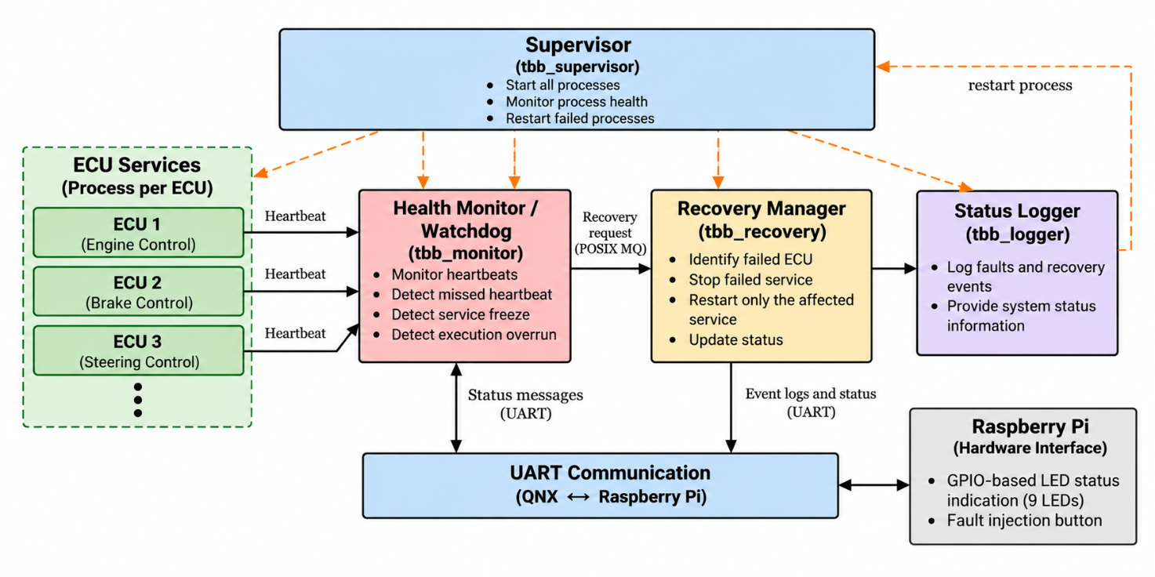
Figure 1. System Architecture of the ECU Watchdog & Recovery Framework
The main components of the system are:
- ECU Services: Engine Control, Brake Control, and Steering Control, each implemented as an independent QNX process.
- Health Monitor / Watchdog: Monitors ECU heartbeats and detects service failures.
- Recovery Manager: Performs selective recovery by restarting only the failed ECU service.
- Status Logger: Records fault detection, recovery events, and system status.
- UART Communication: Provides communication between the QNX system and Raspberry Pi.
- Raspberry Pi Hardware Interface: Provides GPIO-based LED status indication and a fault-injection button.
- Supervisor: Starts and monitors the required system processes and supports process recovery.
- 6. QNX Architecture
QNX Sentinel is designed using the QNX Neutrino real-time operating system to monitor three independent ECU processes: Engine ECU, Brake ECU, and Steering ECU. The architecture uses process separation, POSIX threads, named channels, and synchronous message passing to support
communication between the ECU services and the watchdog component.

6.1 Process Isolation
Each ECU is implemented as a separate process. This separation allows the system to identify and manage faults associated with an individual ECU rather than treating all ECU services as one application.
The Engine, Brake, and Steering ECU programs maintain their own execution logic and heartbeat-generation mechanisms. A fault affecting one ECU can therefore be investigated independently while monitoring the activity of the remaining ECU services.

6.2 Inter-Process Communication
The supplied ECU source files use QNX named channels and message-passing functions for communication.
The main communication functions include:
- name_attach() — registers a named communication endpoint for an ECU.
- name_open() — opens a connection to a named endpoint.
- MsgSend() — sends a message and waits for the receiving process to respond.
- MsgReceive() — receives incoming messages.
- MsgReply() — replies to a received message.
- MsgError() — reports an error for an unsupported or invalid message.
The ECU programs use these mechanisms to send heartbeat messages to the watchdog and receive fault-injection or status-query requests where supported by the individual ECU implementation.

6.3 Multithreading
The ECU implementations use POSIX threads through pthread_create() to separate communication handling from other execution activities.
For example, the Brake ECU has a separate message-handling thread, while its main thread generates heartbeats. This design allows the communication thread to continue handling messages even when the main thread is deliberately blocked by the simulated deadlock fault.
The Steering ECU also separates message handling and steering-task execution into different threads.

6.4 Watchdog and Recovery Integration
The watchdog is responsible for evaluating ECU health based on the monitoring mechanism implemented in the project. When a fault is identified, the recovery component attempts to restore the affected ECU service.
Runtime logs provide evidence of Engine ECU heartbeat-failure detection and recovery activity, as well as Brake ECU deadlock-related detection and process restart activity. The supplied runtime evidence also shows heartbeat messages from other ECU services during these events.
The detailed recovery implementation, watchdog timeout configuration, and process-management APIs should be documented using the corresponding watchdog and recovery source files.

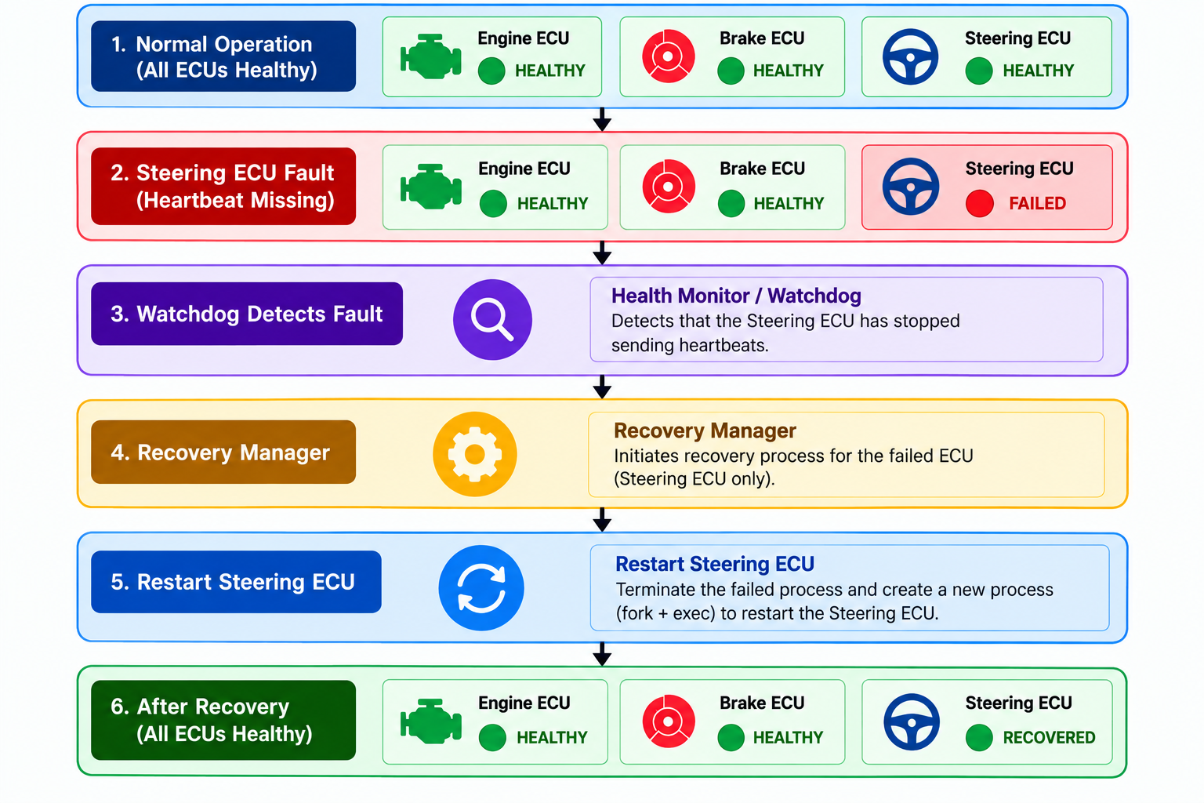

6.5 Recovery Manager and Supervisor
The Recovery Manager is responsible for restoring an ECU service after a fault has been detected. The intended recovery sequence consists of identifying the affected ECU, initiating recovery, restarting the affected process, and checking whether normal heartbeat activity resumes.
Runtime logs demonstrate Engine ECU heartbeat-failure detection and recovery activity, along with Brake ECU deadlock-related detection and process restart activity. Heartbeat activity from other ECU services is also visible during these events.
The detailed process-management implementation should be documented using the Recovery Manager and Supervisor source code. Functions such as fork(), execl(), kill(), waitpid(), and clock_gettime() should be listed as implemented mechanisms only after their use has been verified.
The main architectural objective is selective recovery: restoring the affected ECU service without unnecessarily restarting the entire system.

6.6 GPIO Hardware Interface
The project uses a nine-LED status-indication arrangement to represent the states of the Engine, Brake, and Steering ECU services.
Each ECU is assigned three LEDs:
- Green: ECU healthy
- Yellow: ECU recovery in progress
- Red: ECU failed
ECU | Green LED | Yellow LED | Red LED
Engine | GPIO 17 | GPIO 27 | GPIO 22
Brake | GPIO 23 | GPIO 24 | GPIO 25
Steering | GPIO 5 | GPIO 6 | GPIO 12
The GPIO interface is intended to provide a physical indication of ECU status. The software-to-hardware communication method and the actual LED-control implementation should be documented according to the code and hardware tests performed.
Hardware note: Raspberry Pi GPIO pins operate at 3.3 V logic. LEDs should use appropriate current-limiting resistors; direct connection without resistors can damage the LEDs or GPIO pins.

6.7 Failure Isolation and Recovery Path
The architecture follows a selective failure-recovery sequence:
- ECU processes generate heartbeat messages.
- The watchdog monitors heartbeat activity.
- A missing heartbeat or other supported fault condition triggers fault handling.
- The recovery component attempts to restore the affected ECU service.
- Subsequent heartbeat activity and runtime logs are used to assess whether the service has resumed operation.
The key architectural principle is failure isolation and selective recovery. A fault affecting one ECU should not require restarting healthy ECU services. The effectiveness of this behavior must be evaluated using the observed runtime results.

7. ECU Process Architecture

The QNX Sentinel framework consists of three ECU service processes: Engine ECU, Brake ECU, and Steering ECU. Each ECU maintains its own execution flow and heartbeat-generation mechanism. The ECU services use QNX inter-process communication (IPC) to exchange messages with the watchdog component.
Each process has its own process ID (PID) and execution context. Separating the ECU services allows the framework to monitor individual services and attempt to recover an affected ECU without unnecessarily restarting the other ECU services.
7.1 ECU Processes
The system contains three ECU service processes and a watchdog component responsible for monitoring their health.
Process | Function
Engine ECU | Simulates an engine-control service and generates heartbeat messages.
Brake ECU | Simulates a brake-control service and supports a deadlock fault-injection condition.
Steering ECU | Simulates a steering-control task and supports an execution-delay fault-injection condition.
Watchdog / Health Monitor | Monitors ECU heartbeat activity and handles detected fault conditions.
Fault Injector | Sends fault-injection requests to the selected ECU for testing.
The Engine, Brake, and Steering ECU programs generate heartbeat messages containing information such as the ECU identifier, sequence number, and sender PID. This information helps the receiving watchdog associate heartbeat messages with the corresponding ECU.
7.2 Process Creation and Execution
Each ECU is implemented as a separate executable program. The supplied ECU source files use getpid() to obtain the process ID and pthread_create() to create additional threads for message handling or task execution.
The Supervisor or Recovery Manager may be responsible for starting and restarting ECU executables. However, the exact process-creation mechanism must be verified against its implementation source code before documenting functions such as fork() and execl() as confirmed mechanisms.
The process ID can be used by the process-management component to distinguish between ECU instances and track a restarted service.

7.3 ECU–Watchdog Communication
The supplied ECU source files use QNX named-channel message passing to communicate with the watchdog component.
The communication mechanisms include:
- name_attach() — registers a named communication endpoint.
- name_open() — opens a connection to a named endpoint.
- MsgSend() — sends a message and waits for a response.
- MsgReceive() — receives an incoming message.
- MsgReply() — responds to a received message.
Heartbeat messages contain the ECU identifier and sequence information, allowing the receiving component to associate incoming messages with the relevant ECU service.

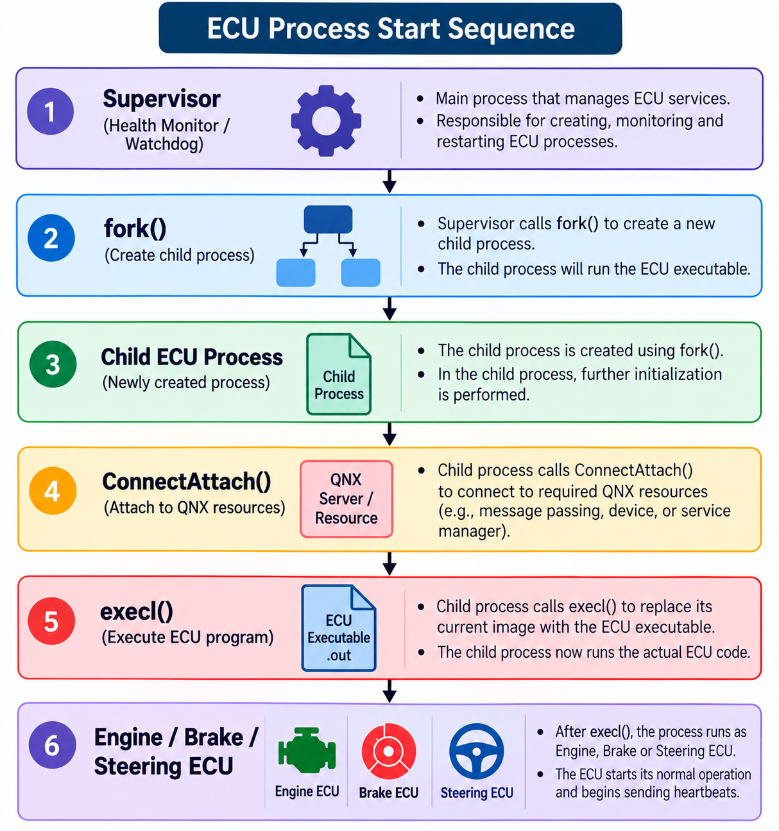
7.4 Process Identification
Each ECU process is associated with a process ID that distinguishes it from other running processes.
The main process-identification mechanism confirmed in the supplied ECU code is:
- getpid() — obtains the process ID of the currently executing ECU process.
The heartbeat message also carries the sender PID, helping the watchdog identify the process that generated the message.
7.5 Process Isolation
Engine, Brake, and Steering are implemented as separate processes. This separation allows the framework to identify a fault associated with one ECU service independently of the others.
Runtime evidence shows Engine ECU recovery activity and Brake ECU deadlock-related recovery activity while heartbeat messages from other ECU services remain visible. These observations support the project's selective-recovery objective.

8. Heartbeat Monitoring and Watchdog Mechanism
The heartbeat and watchdog mechanism forms the primary fault-detection path of the QNX Sentinel – Automotive ECU Watchdog & Recovery Framework. The Engine ECU, Brake ECU, and Steering ECU periodically generate heartbeat messages to indicate their activity. The watchdog monitors these messages to identify missing heartbeat activity and determine whether an ECU may have failed.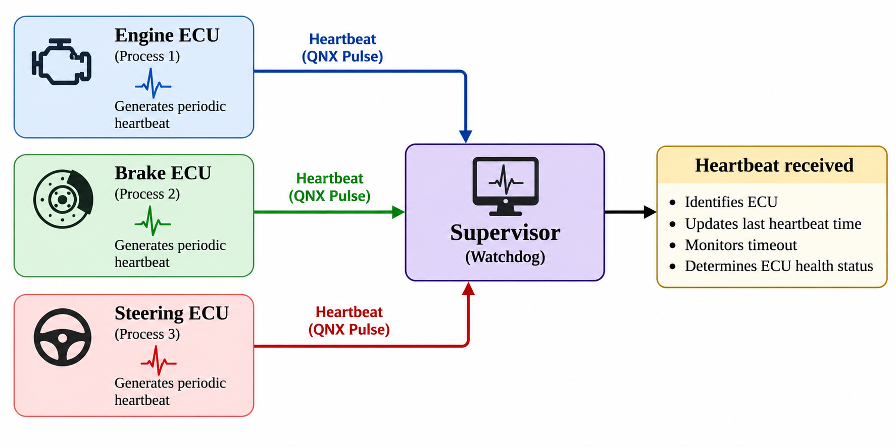
Each heartbeat contains information such as the ECU identifier, sequence number, and sender process ID. This allows heartbeat activity to be associated with the corresponding ECU service.

8.1 Heartbeat Generation
Each ECU process generates periodic heartbeat messages during its normal execution.
The supplied ECU source files implement heartbeat transmission using QNX named-channel communication. The heartbeat message includes the ECU identity, sequence number, and process ID.
The basic sequence is:
- The ECU generates a heartbeat message.
- The message is sent to the watchdog using MsgSend().
- The watchdog receives and processes the message.
- The next heartbeat is generated acco

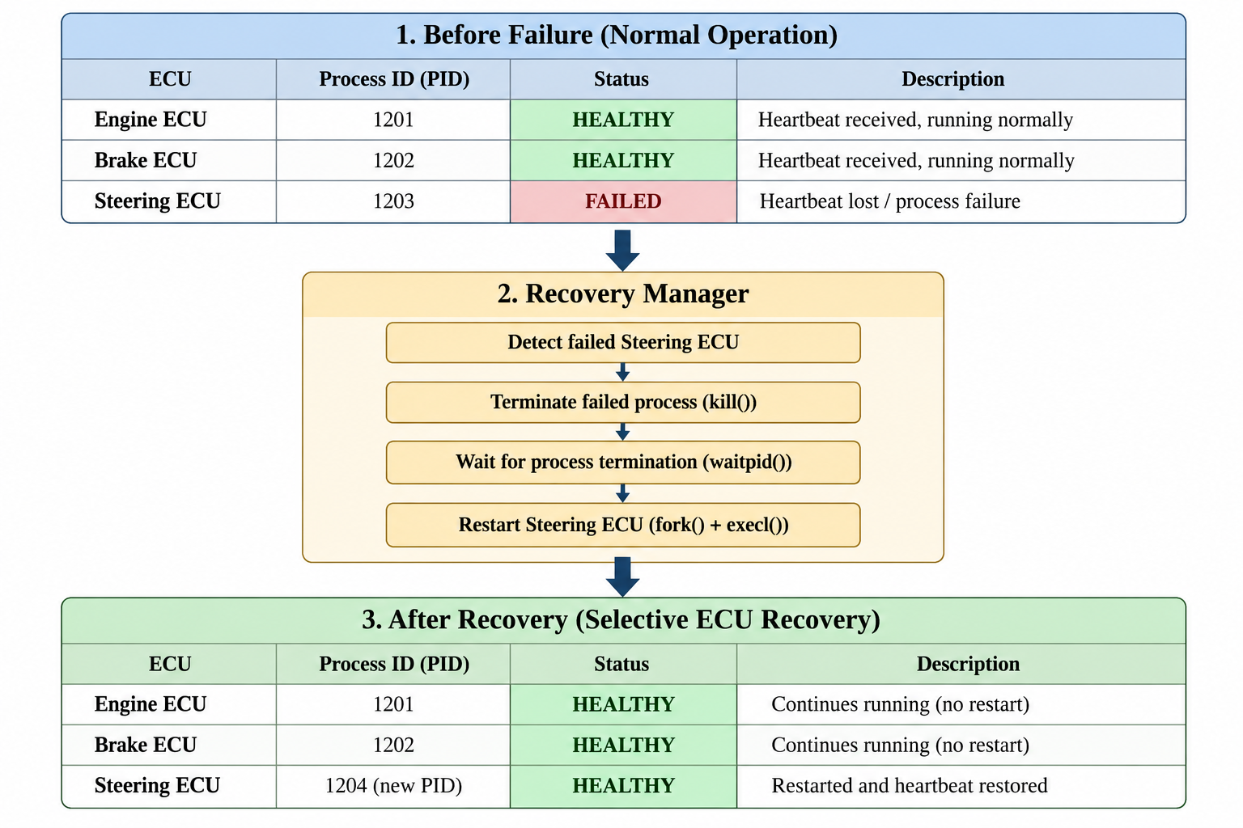According to the ECU's configured execution loop.
8.2 Heartbeat Reception
The ECU source files use QNX named-channel message passing to communicate with the watchdog.
The principal APIs identified in the supplied ECU code are:
- name_attach() — registers a named communication endpoint.
- name_open() — opens a connection to the watchdog endpoint.
- MsgSend() — sends a heartbeat message and waits for a response.
- MsgReceive() — receives incoming messages at an ECU message-handling endpoint.
- MsgReply() — sends a response to a received message.
- getpid() — obtains the current ECU process ID.
8.3 Watchdog Monitoring
The watchdog is responsible for monitoring heartbeat activity from the ECU services. By tracking the latest heartbeat information associated with each ECU, the monitoring mechanism can identify a potential failure when the expected heartbeat is not received within the configured timeout.
The watchdog operates as a separate monitoring component in the system architecture. This separation is intended to allow it to detect faults in individual ECU services without relying entirely on the execution of the affected ECU.

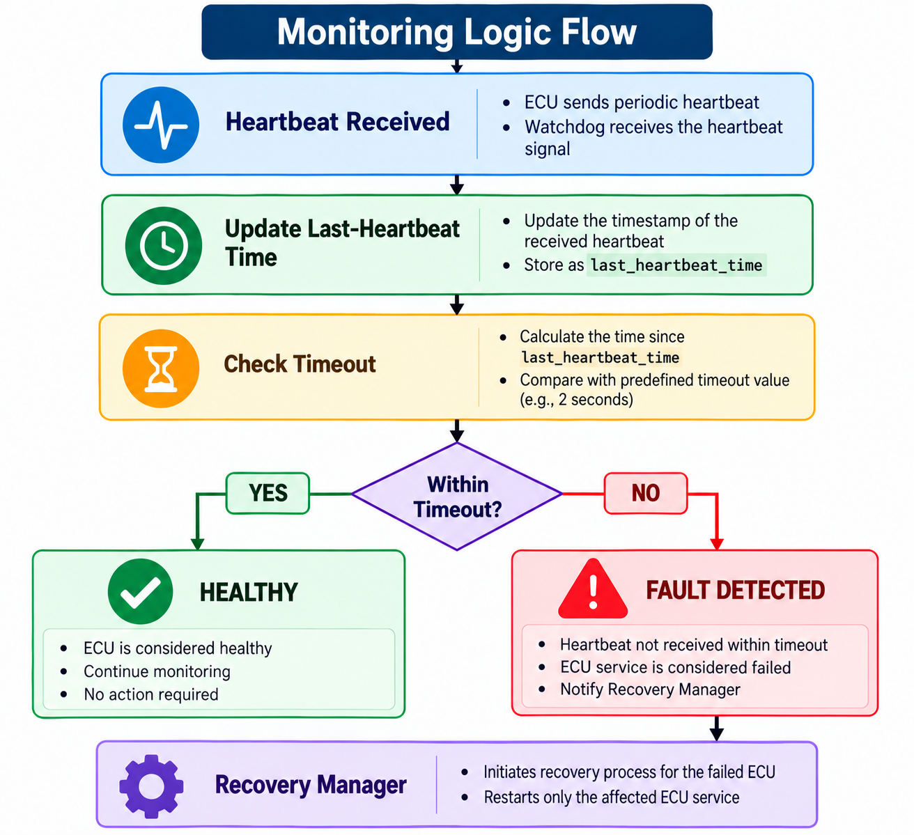
8.4 Fault Conditions
The framework considers several fault conditions for testing and monitoring:
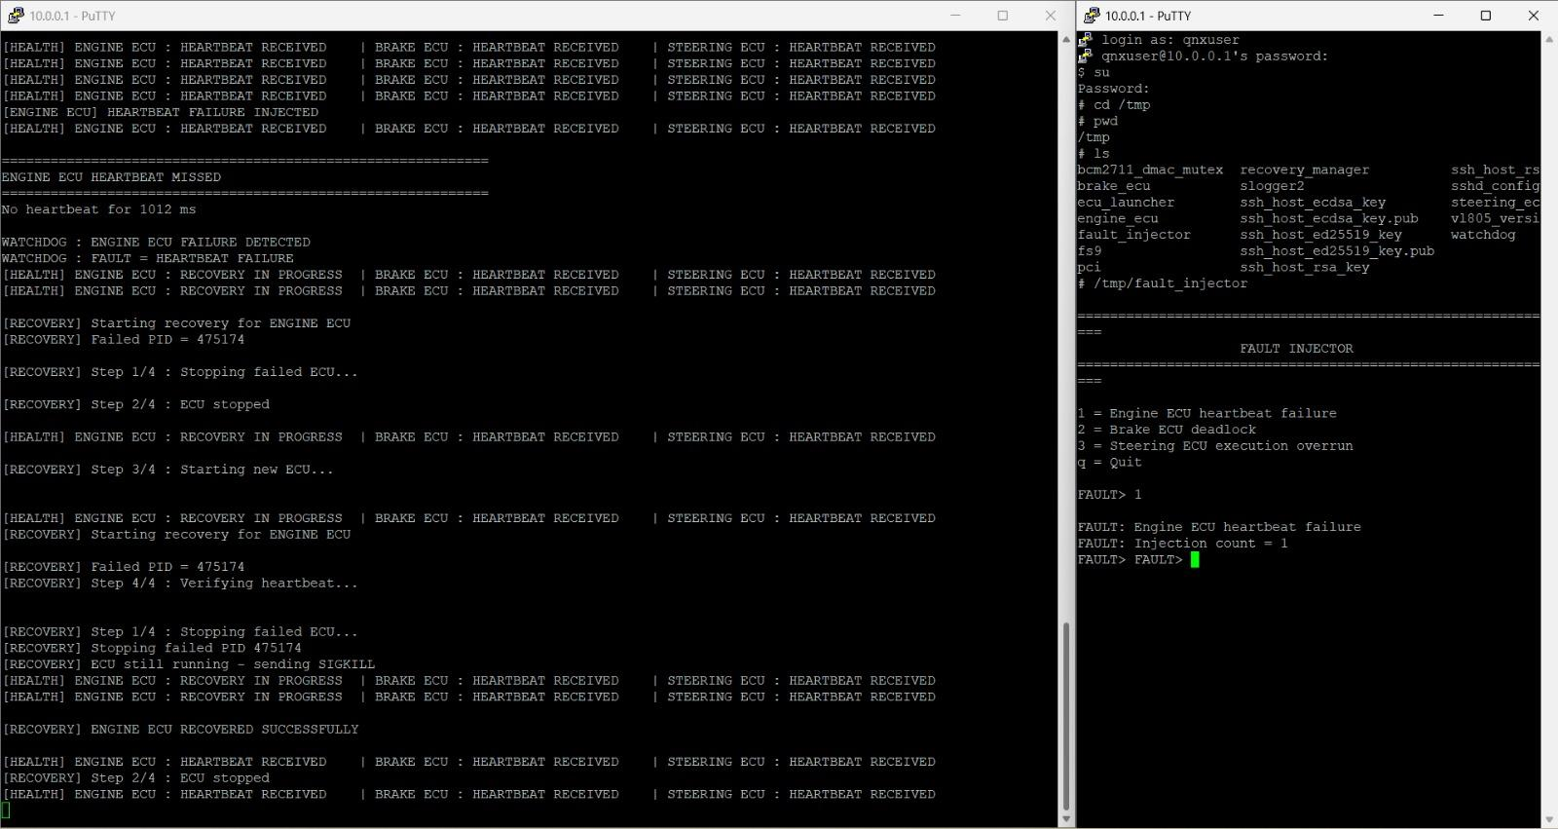
- Missed heartbeat: The ECU stops generating or delivering expected heartbeat messages.
- Simulated deadlock: The ECU's main execution thread becomes blocked, affecting its normal heartbeat generation.
- Execution overrun: An ECU task takes longer than expected to complete.
- Process failure: The ECU process terminates unexpectedly, if process-exit monitoring is implemented.
The fault injector provides options for testing Engine ECU heartbeat failure, Brake ECU deadlock, and Steering ECU execution overrun.
8.5 Watchdog-to-Recovery Sequence
The intended watchdog-to-recovery sequence is:
- The ECU generates heartbeat messages during normal operation.
- The watchdog monitors the heartbeat activity.
- A missing heartbeat or another supported fault condition triggers fault handling.
- The affected ECU is identified.
- The recovery component attempts to restore the ECU service.
- Subsequent heartbeat messages and runtime logs are used to assess whether the service has resumed operation.
Runtime evidence shows Engine ECU heartbeat-failure detection and recovery activity. It also shows Brake ECU deadlock-related detection and process restart activity, while heartbeat messages from other ECU services remain visible.
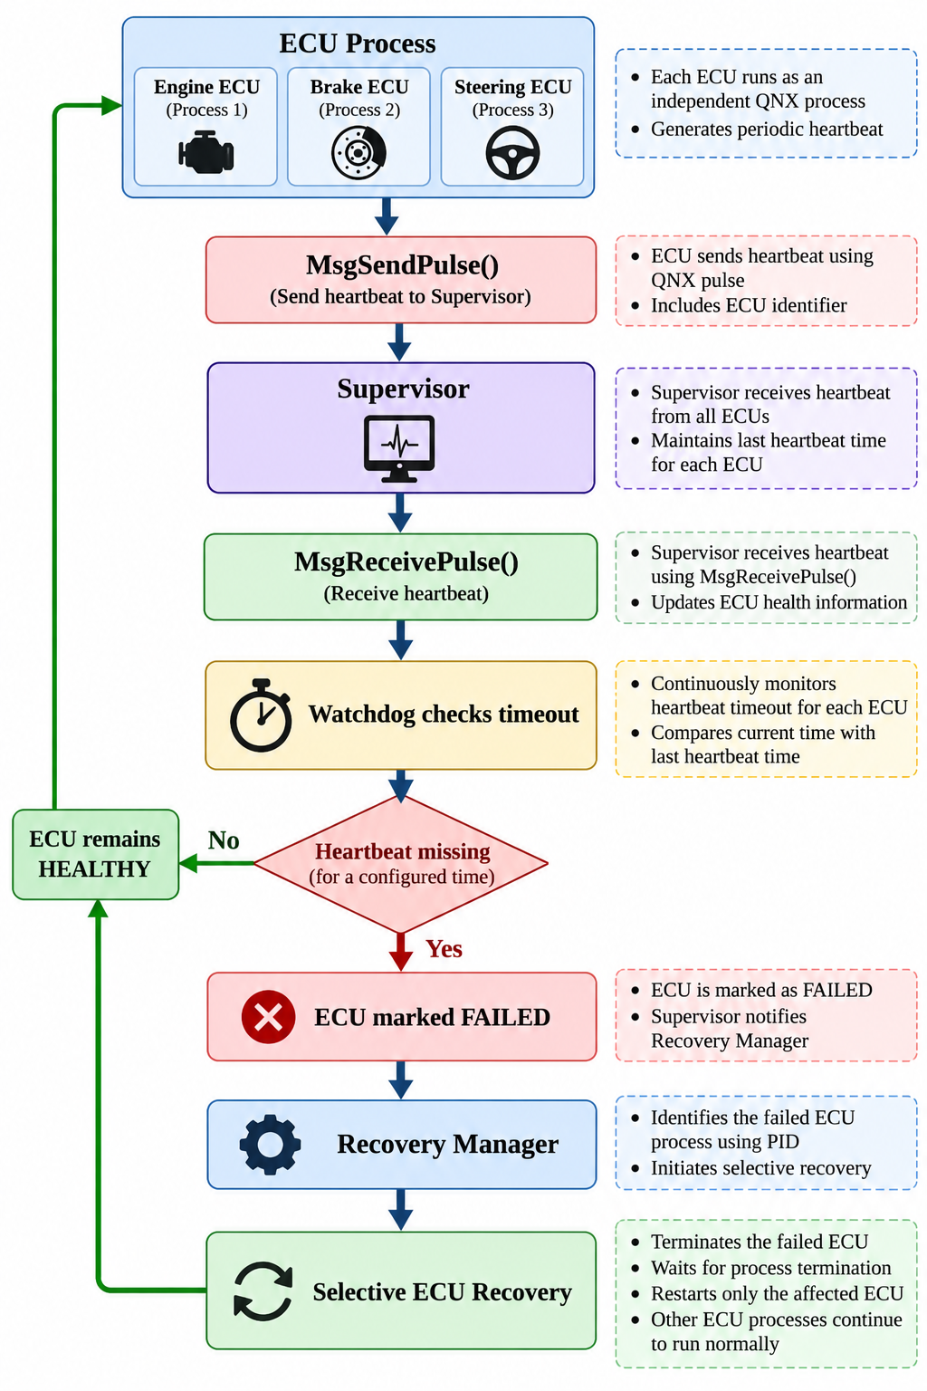

8.6 Health-State Transition
The conceptual health-state transition for an ECU is shown below:
HEALTHY → FAULT DETECTED → RECOVERY IN PROGRESS → HEALTHY
- HEALTHY: Heartbeat activity is being received as expected.
- FAULT DETECTED: The monitoring component identifies a potential fault condition.
- RECOVERY IN PROGRESS: The recovery component attempts to restore the affected ECU service.
- HEALTHY: Heartbeat activity resumes and the service is considered operational according to the implemented verification logic.
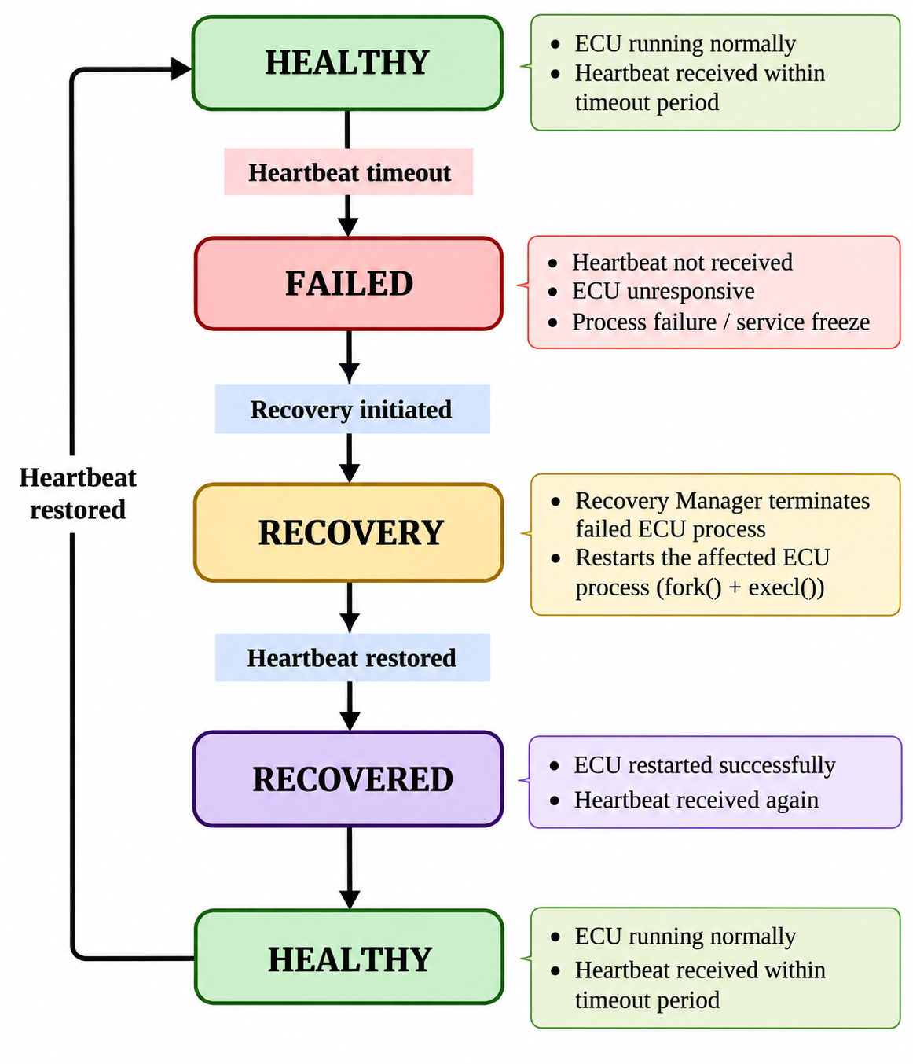
9. Inter-Process Communication (IPC)
Inter-Process Communication (IPC) enables the Engine ECU, Brake ECU, Steering ECU, and watchdog component to exchange information in the QNX Sentinel framework. The system uses QNX named-channel communication to transmit heartbeat messages and handle fault-injection requests.
IPC allows the ECU services to communicate while maintaining their separate process execution contexts.
9.1 QNX Message-Passing Mechanism
The supplied ECU source code uses QNX message-passing functions to communicate with named endpoints.
The principal functions are:
- name_attach() — registers a named communication endpoint.
- name_open() — establishes a connection to a named endpoint.
- MsgSend() — sends a message and waits for a response.
- MsgReceive() — receives a message from a communication channel.
- MsgReply() — replies to a received message.
- MsgError() — reports an error when a message cannot be handled.
These functions support communication between independent processes without requiring the ECU services to execute within the same process.

9.2 Heartbeat Message Communication
Each ECU generates heartbeat messages containing information used to identify the reporting ECU and its activity.
The supplied ECU implementations include fields such as:
- ECU message type
- ECU identifier
- Heartbeat sequence number
- Sender process ID
The ECU sends the heartbeat message to the watchdog through MsgSend(). The receiving component processes the message and responds through the corresponding message-handling mechanism.
The sequence number helps distinguish successive heartbeat messages, while the ECU identifier associates each message with the relevant service.

9.3 Fault-Injection Communication
The Fault Injector provides a command-line interface for selecting fault conditions during testing.
The supported options displayed by the application are:
- Engine ECU heartbeat failure
- Brake ECU deadlock
- Steering ECU execution overrun
The supplied fault_injector.c source uses name_open() to connect to the selected ECU endpoint and MsgSend() to deliver a fault-injection request.
The ECU message-handling thread processes supported requests. For example, the Engine ECU can disable heartbeat generation, while the Brake ECU can request the simulated deadlock condition.
This mechanism allows fault scenarios to be triggered in a controlled manner during testing.

9.4 Message Handling and Threads
The ECU programs use POSIX threads to separate message handling from other execution activities.
The Engine and Brake ECU implementations create message-handling threads using pthread_create(). The Steering ECU also separates message handling from its steering-task execution.
This structure allows an ECU to process supported incoming requests independently of its main execution loop. The exact behavior during a fault depends on which thread is affected and how the fault condition is implemented.

9.5 Role of IPC in Selective Recovery
IPC provides the communication path needed for heartbeat monitoring and fault-injection testing. The watchdog uses the information received from ECU services to evaluate their activity, while the recovery component attempts to restore a service when a supported fault is detected.
Runtime evidence shows heartbeat messages from the Engine, Brake, and Steering ECUs during normal operation. The fault-injection tests also show Engine heartbeat-failure detection and Brake deadlock-related recovery activity.
10. FAULT DETECTION AND FAULT INJECTION
Fault injection is used in the QNX Sentinel framework to evaluate the behavior of ECU services under simulated failure conditions. The Fault Injector provides a command-line interface through which a user can select a fault scenario and send a request to the corresponding ECU process.
The project includes three fault-injection scenarios: Engine ECU heartbeat failure, Brake ECU deadlock, and Steering ECU execution overrun. These scenarios help evaluate the watchdog's ability to identify abnormal ECU behaviour and initiate the recovery process.

10.1 Fault-Injection Mechanism
The supplied fault_injector.c source implements a command-line menu with the following options:
Option | ECU |  | Fault scenario
1 | Engine ECU |  | Heartbeat failure
2 | Brake ECU |  | Simulated deadlock
3 | Steering ECU |  | Execution overrun
q | — |  | Quit the fault injector
When a fault is selected, the Fault Injector opens the named endpoint of the target ECU and sends a fault-injection message using QNX message-passing functions.
The selected ECU's message-handling logic processes the request and activates the corresponding fault condition where supported.

10.2 Engine ECU Heartbeat Failure
The Engine ECU supports a fault-injection request that disables its heartbeat generation. This allows the watchdog to observe a period without receiving the expected Engine ECU heartbeat messages.
During the demonstrated test, the runtime output displayed an Engine ECU heartbeat-missed interval of 1012 ms, followed by a watchdog failure-detection message and recovery activity.
The recovery logs showed attempts to stop the failed ECU, start a new ECU instance, and verify heartbeat activity. The output also displayed the message ENGINE ECU RECOVERED SUCCESSFULLY.
This evidence demonstrates Engine ECU heartbeat-failure detection and recovery activity during the recorded test.

10.3 Brake ECU Deadlock
The Brake ECU supports a simulated deadlock condition. According to the supplied source code, the fault request causes the main execution thread to block by attempting to lock the same normal mutex twice.
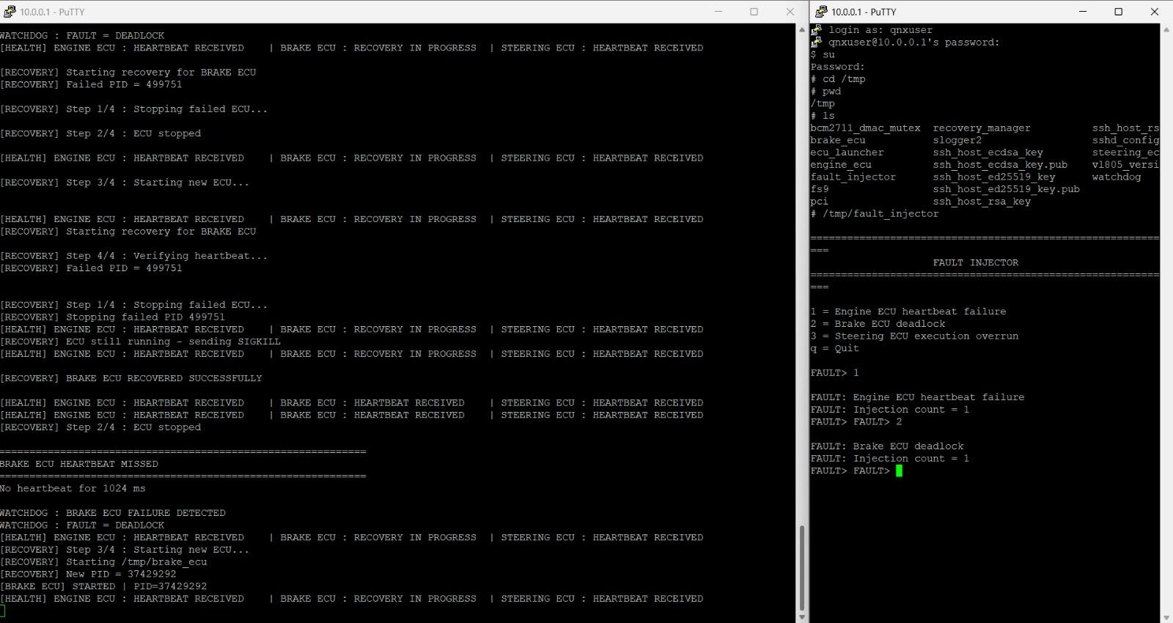
During the demonstrated test, the runtime output displayed a Brake ECU heartbeat-missed interval of 1024 ms, followed by a watchdog message identifying a deadlock-related fault.
The recovery logs showed the recovery manager attempting to stop the affected Brake ECU process and start a new instance with a different process ID. Heartbeat messages from the Engine and Steering ECUs remained visible during the recovery activity.
This test provides evidence of Brake ECU deadlock-related detection and process-restart activity.

10.4 Steering ECU Execution Overrun
The Steering ECU source includes a fault-injection mechanism that adds a configured delay to the steering-control task when an overrun is requested. The task measures its execution duration and sends a task-completion message.
This scenario is intended to evaluate the system's handling of an ECU task that takes

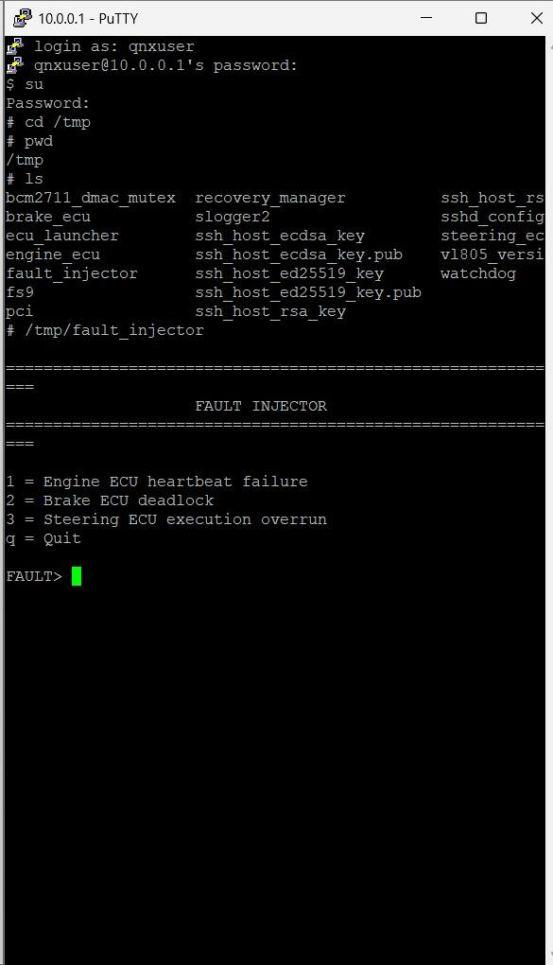

10.5 Fault-Detection and Recovery Verification
The recorded runtime evidence supports the following observations:
Fault scenario | Evidence available | Verification status
Engine heartbeat failure | Heartbeat-missed message, watchdog detection, recovery logs | Detection and recovery activity observed
Brake deadlock | Heartbeat-missed message, deadlock identification, process-restart logs | Detection and recovery activity observed
Steering execution overrun | Fault-injection option and source-code implementation | Successful detection and recovery not yet verified by the available screenshots

11. RECOVERY MANAGER AND SELECTIVE ECU RECOVERY
The Recovery Manager is responsible for attempting to restore an ECU service after a fault has been detected. The main objective is to recover the affected ECU process without unnecessarily restarting the entire system or other healthy ECU services.
In QNX Sentinel, the recovery workflow identifies the affected ECU, attempts to stop the failed process, starts a new ECU instance, and checks whether the service resumes operation.
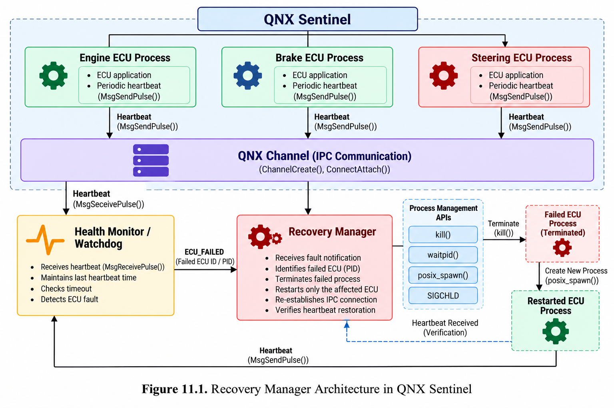

11.1 Recovery Procedure
The recovery procedure shown in the runtime logs consists of the following steps:
- Fault identification: The watchdog identifies the ECU associated with the detected fault.
- Process termination: The Recovery Manager attempts to stop the affected ECU process.
- ECU restart: The Recovery Manager starts a new instance of the selected ECU executable.
- Heartbeat verification: The system checks for renewed heartbeat activity to assess whether the ECU service has resumed.
The runtime output displays these recovery stages for the Engine and Brake ECU test scenarios.

11.2 Engine ECU Recovery
During the Engine ECU heartbeat-failure test, the runtime output displayed a missed heartbeat interval of 1012 ms and a watchdog failure-detection message.
The recovery logs then showed the Recovery Manager attempting to stop the failed Engine ECU,
starting a new ECU instance, and verifying heartbeat activity. The output also displayed the message ENGINE ECU RECOVERED SUCCESSFULLY.
This evidence demonstrates Engine ECU failure detection and recovery activity in the recorded test. The displayed heartbeat-missed interval should not be interpreted as the total recovery duration.
11.3 Brake ECU Recovery
During the Brake ECU deadlock test, the runtime output displayed a missed heartbeat interval of 1024 ms and identified the fault as a deadlock.
The recovery logs showed the Recovery Manager attempting to stop the affected Brake ECU process and starting a new instance. The output displayed a new process ID for the restarted Brake ECU.
Heartbeat messages from the Engine and Steering ECUs remained visible during the recovery activity. This supports the project's objective of recovering the affected ECU while monitoring the other ECU services.

11.4 Selective Recovery
Selective recovery is the central objective of the QNX Sentinel framework. Instead of restarting the entire system when one ECU encounters a fault, the recovery mechanism attempts to restore only the affected ECU service.
The recorded Engine and Brake ECU tests show recovery activity for the selected ECU while heartbeat messages from the other ECU services remain visible.
This behavior supports the selective-recovery design objective. However, uninterrupted operation of the other ECU services and successful recovery should be assessed separately for each test using complete runtime logs.

11.5 Recovery Verification
Recovery verification is necessary to determine whether the restarted ECU has resumed normal operation.
The verification evidence used in this project includes:
- Recovery-manager log messages indicating the recovery stages.
- Process ID information for the affected ECU.
- Heartbeat messages following the recovery attempt.
- Heartbeat activity from the other ECU services during recovery.

12. PRIORITY SCHEDULING AND REAL-TIME OPERATION
QNX is a real-time operating system designed to support concurrent processes and threads with predictable scheduling behavior. In the QNX Sentinel framework, the Engine, Brake, and Steering ECU services execute alongside the Watchdog, Recovery Manager, ECU Launcher, and Fault Injector. Their execution and interaction were examined using QNX Momentics System Profiler.
The purpose of this evaluation is to observe concurrent ECU execution, CPU activity across multiple cores, thread execution timelines, and inter-CPU communication during the captured trace interval.

12.1 Concurrent Process and Thread Execution
The QNX Sentinel architecture separates the ECU services and monitoring components into individual processes. Each ECU process contains its own execution threads, while the Watchdog and Recovery Manager perform supporting monitoring and recovery functions.
The System Profiler timeline displays execution activity associated with:
- engine_ecu
- brake_ecu
- steering_ecu
- watchdog
- recovery_manager
- fault_injector
- ecu_launcher
The timeline also displays individual threads within these processes, allowing their execution activity to be inspected over the captured interval.
Observed result: The profiler trace contains visible thread activity for the ECU services and supporting components. This provides evidence that the processes and threads were present and executing during the recorded session.
Technical interpretation: The timeline helps examine concurrency between the ECU services and monitoring components. However, the screenshot alone does not establish exact scheduling priorities, deadline compliance, or worst-case execution times.

12.2 CPU Usage Analysis
The QNX Momentics CPU Usage view provides a breakdown of the recorded CPU execution time across the four available CPU cores.
The captured profiler view displays the following summary values:
- Total displayed CPU usage: 92.246 ms
- CPU 0: 37.286 ms
- CPU 1: 31.555 ms
- CPU 2: 17.754 ms
- CPU 3: 5.649 ms
These values represent the CPU usage summary displayed in the captured profiler view. The displayed total corresponds to the sum of the four per-CPU values.
Technical interpretation: The recorded values show that execution time was distributed across the four CPU cores during the captured interval. CPU 0 had the largest displayed value, followed by CPU 1, CPU 2, and CPU 3.
These values are reported in milliseconds, not percentages. They should not be interpreted as average CPU utilization or as a complete measure of system performance. The CPU Activity view provides a separate visualization of utilization changes over the trace interval.

12.3 CPU Activity Across Four Cores
The CPU Activity screenshot displays utilization plots for CPU 0, CPU 1, CPU 2, and CPU 3. The plots show periods of increased activity followed by lower activity, indicating that CPU demand varied during the recorded interval.
Observed result: Activity peaks are visible on multiple CPU cores. The displayed activity is not constant across the interval.
Technical interpretation: The CPU Activity view provides evidence of changing processor activity while the QNX Sentinel processes and other system threads execute. It helps identify periods of higher CPU demand and compare activity across the available cores.

12.4 Process and Thread Timeline Analysis
The System Profiler timeline provides a chronological view of process and thread execution. The captured screenshots show activity associated with the Engine ECU, Brake ECU, Steering ECU, Watchdog, Recovery Manager, Fault Injector, and other system components.
The ECU timelines contain repeated visible activity across the captured interval, while the supporting-process timelines show their own execution patterns.
Observed result: The trace contains visible execution activity for all three ECU services and the principal monitoring and recovery components.
Technical interpretation: This view helps examine how ECU services and supporting components execute concurrently. It can also help investigate periods of inactivity or unexpected execution behavior when detailed event information is available.
The displayed timeline is evidence of execution activity, but it does not alone prove that every heartbeat met its deadline or that all recovery operations completed within a guaranteed time bound.

12.5 CPU Migration Analysis
The CPU Migration view records thread migration events across CPU cores. The captured screenshot includes the following migration counts:
- devc-pty - Thread 1: 146 migrations
- engine_ecu - Thread 1: 6 migrations
- brake_ecu - Thread 1: 5 migrations
- devf-ram - I/O Handler: 26 migrations
Observed result: CPU migration events were recorded for system and ECU-related threads during the captured trace.
Technical interpretation: The migration data shows that some threads executed across different CPU cores during the observed interval. Migration counts can help identify thread-placement behavior and provide a starting point for investigating scheduling overhead.
A migration count alone does not quantify the time cost of migration or prove that migration negatively affected performance. Further controlled profiling would be needed to assess its impact on ECU response time.

12.6 Inter-CPU Communication Analysis
The Inter-CPU Communication view displays cross-CPU receive activity recorded by the profiler. The screenshot lists the following values:
- procnto-smp-instr - Thread 24: 72 cross-CPU messages
- procnto-smp-instr - Thread 23: 33 cross-CPU messages
- procnto-smp-instr - Thread 27: 30 cross-CPU messages
- devc-pty - Thread 1: 25 cross-CPU messages
- watchdog - Thread 2: 4 cross-CPU messages
Observed result: Cross-CPU communication events were recorded for the listed system and Watchdog threads.
Technical interpretation: These observations show that inter-CPU communication occurred during the captured trace. Such events are relevant to understanding how work and synchronization are coordinated in a multicore operating system.
The listed counts do not identify the complete communication path of every ECU message, nor do they measure IPC latency. The profiler view also does not establish that each cross-CPU event originated from the ECU heartbeat mechanism.

12.7 Real-Time Monitoring and Fault-Handling Context
The profiler views complement the runtime evidence collected during the Engine and Brake fault-injection tests. The runtime logs recorded missed-heartbeat intervals of 1012 ms for the Engine ECU and 1024 ms for the Brake ECU. The Engine recovery-success message and the new Brake ECU process ID were also observed during the respective recovery scenarios.
These runtime observations and the profiler trace provide different types of evidence:
- Runtime logs show heartbeat-related detection and recovery messages.
- System Profiler timelines show process and thread execution activity.
- CPU Usage and CPU Activity views show recorded processor activity.
- CPU Migration and Inter-CPU Communication views show migration and cross-CPU communication events.
The missed-heartbeat intervals are not measurements of total fault-detection latency or recovery duration. The profiler screenshots also do not provide paired fault-injection and detection timestamps from which to calculate those values.

12.8 Trace Scope and Limitations
The detailed profiler views display a trace interval of approximately 749.943 ms. The measurements in this section therefore describe the captured interval and should not be generalized to long-duration operation.
The current evidence supports observations of CPU activity, thread timelines, CPU migration, and inter-CPU communication. However, it does not establish:
- Explicit scheduling priorities for every project thread.
- Worst-case execution times or scheduling latency.
- Guaranteed deadline compliance for the ECU services.
- The complete latency of heartbeat detection or ECU recovery.
- The performance impact of individual CPU migrations.
- Long-duration CPU utilization or system stability.
These values require additional trace-event analysis, controlled experiments, or timestamped runtime measurements.

The QNX Momentics System Profiler evidence demonstrates concurrent execution activity across the QNX Sentinel ECU services and supporting processes. The captured views provide recorded CPU usage values, CPU activity across four cores, thread timelines, CPU migration counts, and inter-CPU communication counts.

13. GPIO HARDWARE INTEGRATION
The QNX Sentinel project includes a hardware demonstration using a Raspberry Pi and nine LEDs to represent the status of the Engine ECU, Brake ECU, and Steering ECU. Each ECU is assigned three LEDs corresponding to healthy, recovery-in-progress, and failed states.
The hardware setup consists of the Raspberry Pi board, a breadboard, nine LEDs, and jumper wires. The physical arrangement provides a visual representation of ECU status during the demonstration.

13.1 Hardware Integration Overview
The hardware demonstration uses the Raspberry Pi GPIO interface for LED-based status indication. The nine LEDs are arranged in three groups, with each group representing one ECU service.
The hardware setup is shown in Figure 13.1. The photographs document the physical arrangement of the Raspberry Pi, breadboard, LEDs, and connecting wires.
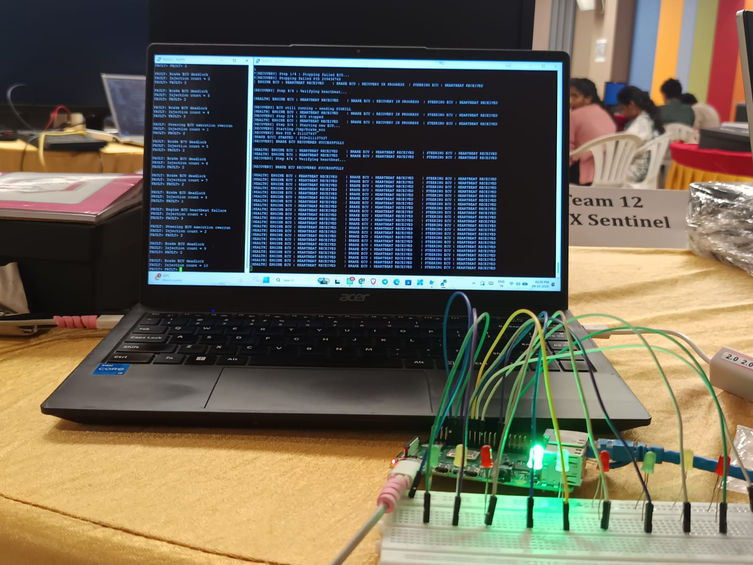
13.2 GPIO Pin Mapping
The documented GPIO assignment for the three ECU services is shown below.
ECU | Green LED | Yellow LED | Red LED
Engine ECU | GPIO 17 | GPIO 27 | GPIO 22
Brake ECU | GPIO 23 | GPIO 24 | GPIO 25
Steering ECU | GPIO 5 | GPIO 6 | GPIO 12
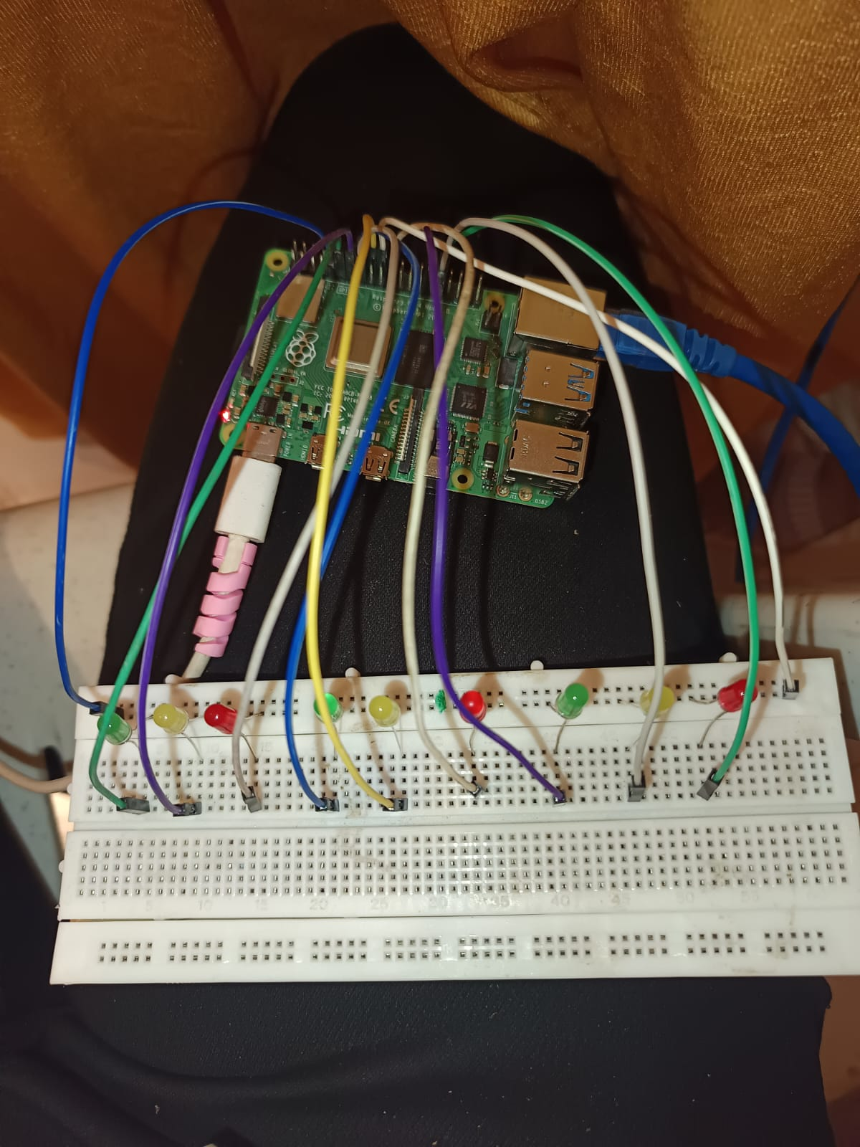
These assignments represent the documented pin mapping. The final report should confirm that the physical wiring and GPIO-control code match these assignments.

13.3 LED Status Indication
The intended LED status convention is:
- Green LED: ECU healthy.
- Yellow LED: Recovery in progress.
- Red LED: ECU failed.
This arrangement is intended to make ECU status easier to interpret during normal operation and fault-recovery demonstrations. The LED behavior for each state should be reported as demonstrated only when supported by the corresponding GPIO-control test.

13.4 Hardware and Software Demonstration
The photographs show the Raspberry Pi and LED circuit arranged alongside the laptop displaying the QNX Sentinel runtime output. This provides visual evidence of the physical demonstration setup.
The hardware photographs establish that the components were assembled. They do not, by themselves, verify the GPIO pin assignments, the software-to-LED mapping, or whether all nine LEDs change state correctly during fault injection.

13.5 Hardware Validation and Safety
Hardware validation should confirm that each LED is associated with the intended ECU and that its state corresponds to the software status.
The validation process should include checking the wiring, confirming the GPIO pin assignments, and testing the expected LED behavior during healthy operation, recovery, and failure conditions.
Raspberry Pi GPIO pins operate at 3.3 V logic.
14. PERFORMANCE EVALUATION
The performance evaluation of QNX Sentinel focuses on heartbeat monitoring, fault detection, ECU recovery, and the continuity of other ECU services during a fault. The evaluation is based on runtime logs captured during normal operation, Engine ECU heartbeat-failure testing, and Brake ECU deadlock testing.

14.1 Performance Evaluation Parameters
The following parameters are used to evaluate the performance of the QNX Sentinel framework.
Parameter | Purpose
Engine ECU heartbeat-missed interval | The application reported a missed-heartbeat interval of 1012 ms during the observed Engine ECU test.
Brake ECU heartbeat-missed interval | The application reported a missed-heartbeat interval of 1024 ms during the observed Brake ECU test.
Fault-detection latency | Measures the time between fault injection and watchdog detection.
ECU recovery time | Measures the time between fault detection and confirmed restoration of heartbeat activity.
Service restoration | Checks whether the affected ECU resumes heartbeat transmission after recovery. An Engine ECU recovery-success message was observed in the logs.
Healthy-service continuity | Checks whether other ECU services continue reporting heartbeats during recovery. Their heartbeat messages remained visible in the recorded logs.
Recovery success rate | Measures the percentage of fault-injection trials that successfully restore the affected ECU service.
Steering overrun response time | Measures the time taken to detect and respond to the Steering ECU execution-overrun condition.
The values of 1012 ms and 1024 ms are the heartbeat-missed intervals displayed by the application. They are not measurements of total recovery time.

14.2 Observed Runtime Results
The following results were observed in the available runtime screenshots.
Test scenario | Observed result | Evaluation
Normal operation | Heartbeat messages displayed for Engine, Brake, and Steering ECUs. | Normal heartbeat activity observed.
Engine heartbeat failure | Heartbeat-missed interval of 1012 ms, followed by watchdog detection and recovery logs. | Failure detection and recovery activity observed.
Brake deadlock | Heartbeat-missed interval of 1024 ms, followed by deadlock identification and recovery logs. | Deadlock-related detection and process-restart activity observed.
Other ECU services | Heartbeat messages from the other ECU services remained visible during the recorded recovery activity. | Continued heartbeat reporting observed in the displayed logs.
Steering execution overrun | Fault-injection option and source-code implementation are available. | Successful detection and recovery are verified

14.3 Fault-Detection Latency
Fault-detection latency is the time elapsed between injecting a fault and the watchdog identifying it.
Formula:
Fault-detection latency = Watchdog detection time − Fault-injection time

14.4 ECU Recovery Time

Recovery time measures the time taken to restore the affected ECU service after fault detection.
Formula:
Recovery time = Confirmed service-restoration time − Fault-detection time
The Engine ECU logs display a recovery-success message, while the Brake ECU logs show process-restart activity.
To obtain this metric, record the watchdog detection timestamp and the timestamp of the first confirmed heartbeat from the restarted ECU.

14.5 Healthy-Service Continuity
Healthy-service continuity evaluates whether ECU services not selected for recovery continue reporting heartbeats while the affected ECU is being recovered.
During the recorded Engine and Brake ECU tests, heartbeat messages from the other ECU services remained visible in the runtime output. This supports the selective-recovery objective of QNX Sentinel.
However, uninterrupted operation throughout the complete recovery interval should be confirmed using complete, timestamped logs.

14.6 Recovery Success Rate
Recovery success rate measures how consistently the framework restores an affected ECU service across repeated fault-injection trials.
Formula:
Recovery success rate (%) = (Number of successful recovery trials ÷ Total number of fault-injection trials) × 100
The available screenshots show recovery activity for the Engine and Brake ECU tests, but they do not establish the total number of trials performed.
14.7 Performance Evaluation Summary
The available runtime evidence demonstrates normal heartbeat reporting and fault-detection and recovery activity for the Engine and Brake ECU test scenarios. The observed heartbeat-missed intervals were 1012 ms for the Engine ECU and 1024 ms for the Brake ECU.
Heartbeat messages from other ECU services remained visible during the displayed recovery periods, supporting the project's selective-recovery objective.
A more complete quantitative evaluation should include repeated trials, measured fault-detection latency, total recovery time, confirmed post-recovery heartbeat reception, and recovery success rate. These measurements would provide a stronger assessment of the framework's performance and reliability.
The observed runtime results provide preliminary evidence of heartbeat monitoring and recovery activity in QNX Sentinel. Further timestamped testing is required to quantify recovery performance and establish numerical reliability metrics.

15. QNX SYSTEM PROFILER ANALYSIS
The QNX Sentinel framework was monitored using the QNX Momentics IDE connected to the Raspberry Pi 4B target running QNX 8.0.0. The evaluation used the System Summary, process-monitoring view, and QNX System Profiler kernel-event trace to inspect the target configuration, memory status, running processes, CPU activity, thread execution timelines, CPU migration, and inter-CPU communication.
The System Summary and process-monitoring screenshots document the system state during the captured session. The System Profiler trace provides additional execution-level information over a displayed interval of approximately 749.943 ms in the detailed views. These sources are used together to examine the execution behavior of the ECU services and supporting components.

15.1 System Summary
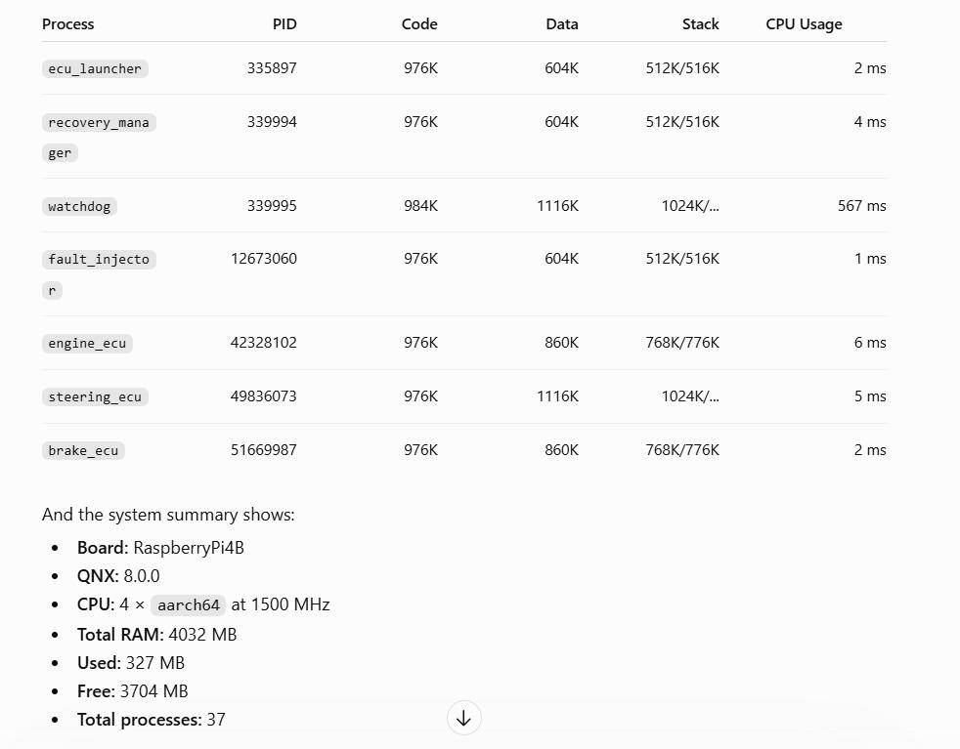
Figure 15.1. QNX Momentics System Summary showing the Raspberry Pi target configuration, memory status, CPU configuration, and total process count.

What it shows
The System Summary displays the following system information:
- Target board: RaspberryPi4B
- QNX version: 8.0.0
- CPU architecture: AArch64
- CPU cores: 4
- Displayed CPU frequency: 1500 MHz
- Total memory: 4032 MB
- Used memory: 327 MB
- Free memory: 3704 MB
- Total processes: 37

What it means
The captured system was running QNX 8.0.0 on a Raspberry Pi 4B with four AArch64 CPU cores operating at a displayed frequency of 1500 MHz. The System Summary reported 327 MB of used memory and 3704 MB of free memory out of 4032 MB total.
The used and free memory values sum to 4031 MB, which differs from the displayed total by 1 MB. The values are retained as shown in the screenshot.
These measurements provide a baseline for understanding the hardware environment in which the ECU services, Watchdog, Recovery Manager, and Fault Injector were running. They describe the system at the time of capture and do not represent peak memory consumption or long-term resource utilization.

15.2 Process-Level Monitoring
Figure 15.2. QNX Momentics process-monitoring view showing ECU services and supporting processes with their process IDs, memory-related fields, stack information, and displayed CPU usage values.

What it shows
The process table contains the main QNX Sentinel components. Selected entries from the screenshot are listed below:
- ecu_launcher — PID 335897; displayed CPU usage: 2 ms
- recovery_manager — PID 339994; displayed CPU usage: 4 ms
- watchdog — PID 339995; displayed CPU usage: 567 ms
- fault_injector — PID 12673060; displayed CPU usage: 1 ms
- engine_ecu — PID 42328102; displayed CPU usage: 6 ms
- steering_ecu — PID 49836073; displayed CPU usage: 5 ms
- brake_ecu — PID 51669987; displayed CPU usage: 2 ms
The screenshot also displays code size, data size, stack information, and CPU-usage fields.

What it means
The process table confirms that the ECU services and supporting QNX Sentinel components were present in the monitored process list at the time of capture. The displayed process IDs distinguish individual process instances and can help identify a process that is restarted during recovery.
The CPU-usage values are reproduced as displayed by Momentics. They are expressed in milliseconds, not percentages, and the screenshot does not establish the sampling interval needed to interpret them as average CPU utilization. Consequently, they should not be used to claim a particular sustained CPU load or a real-time performance guarantee.

15.3 ECU Process and Resource Analysis
The process-monitoring view provides per-process information that can be used to inspect the execution environment of the ECU services and supporting components.

What it shows
The monitored process list includes:
- engine_ecu, brake_ecu, and steering_ecu — the three ECU services.
- watchdog — the heartbeat-monitoring component.
- recovery_manager — the recovery component.
- ecu_launcher — the ECU launching component.
- fault_injector — the command-line fault-injection component.
The screenshot also displays memory-related fields and stack information for these processes.

What it means
The process-level view provides evidence that the project components were present in the running QNX environment. Process IDs can also be compared with recovery logs to investigate whether an affected ECU was replaced by a new process instance.
However, a single screenshot cannot establish the complete process lifecycle, peak resource consumption, or behavior across repeated fault-injection trials. Those observations require additional captures or timestamped monitoring records.

15.4 CPU Usage Analysis
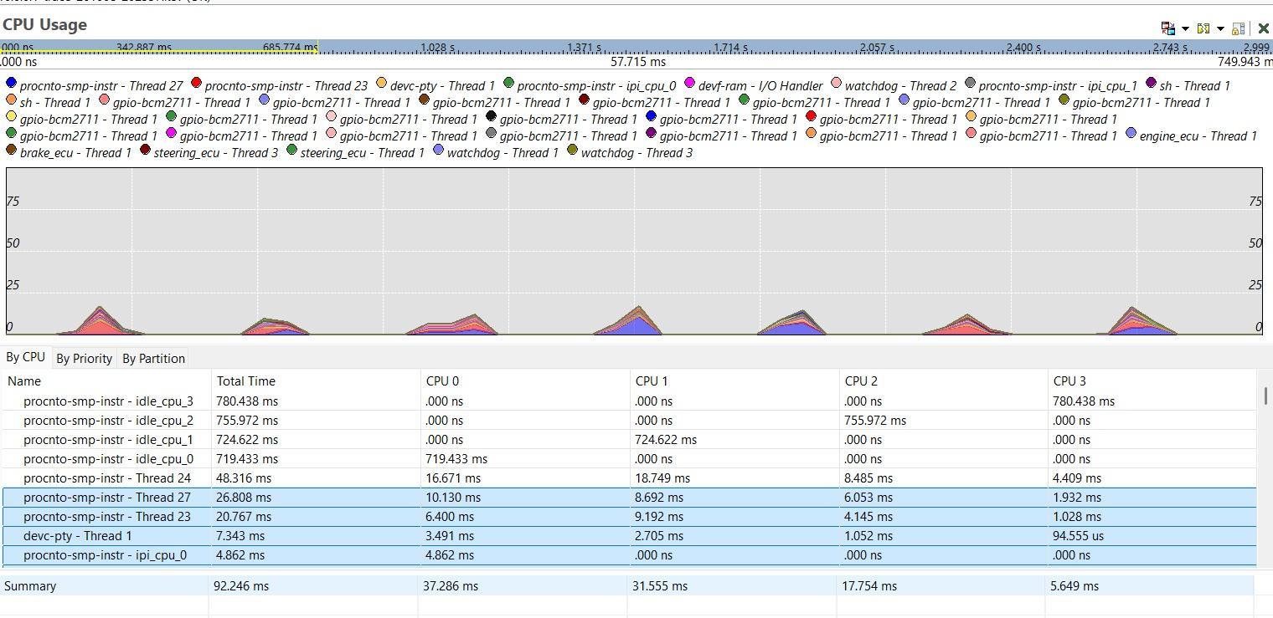
Figure 15.3. QNX System Profiler CPU Usage view showing per-thread execution-time values and the displayed summary across four CPU cores.

What it shows
The CPU Usage view displays the following summary values:
- Displayed CPU usage summary: 92.246 ms
- CPU 0: 37.286 ms
- CPU 1: 31.555 ms
- CPU 2: 17.754 ms
- CPU 3: 5.649 ms
The four per-CPU values sum to the displayed total of 92.246 ms.

What it means
The recorded values show that execution time was distributed across the four CPU cores during the captured interval. CPU 0 had the largest displayed value, followed by CPU 1, CPU 2, and CPU 3.
These values are measured in milliseconds and should not be interpreted as utilization percentages. The profiler's CPU Usage view also includes per-thread and per-CPU information, which helps examine where execution time was recorded.
The values describe the selected profiler summary and do not independently establish average CPU utilization, maximum workload capacity, or the CPU cost of a specific ECU operation.

15.5 CPU Activity Analysis
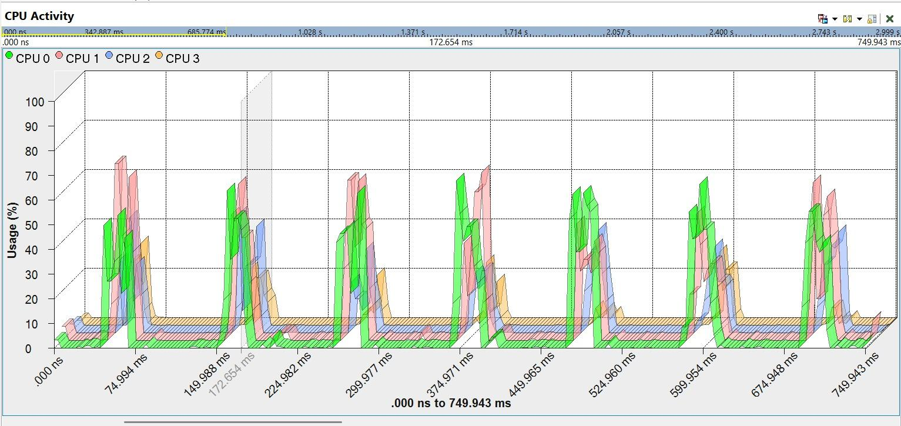
Figure 15.4. QNX System Profiler CPU Activity view displaying activity across CPU 0, CPU 1, CPU 2, and CPU 3.

What it shows
The CPU Activity graph displays utilization plots for all four CPU cores. The graph contains repeated increases in activity followed by lower activity levels across the displayed interval.

What it means
The observed peaks indicate that processor activity varied over time rather than remaining constant. The graph provides a visual representation of changing CPU demand and allows the activity patterns of the four cores to be compared.
This evidence helps characterize processor activity during the recorded session. However, it does not establish sustained utilization, worst-case CPU load, or the precise contribution of each ECU process without further analysis of the corresponding trace events.

15.6 Process and Thread Timeline Analysis
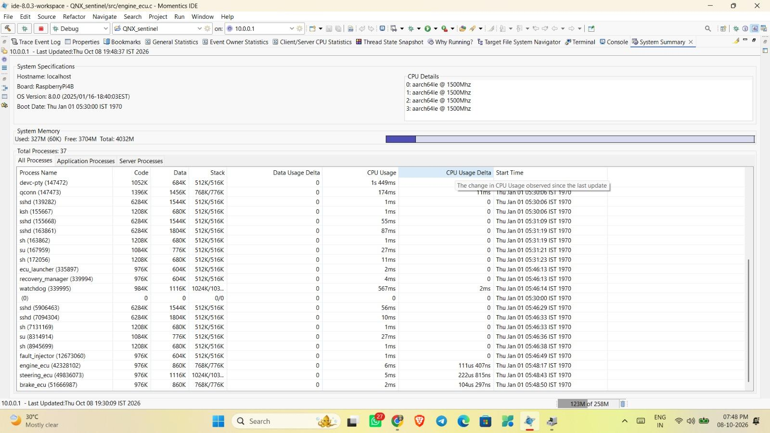
Figure 15.5. QNX System Profiler timeline showing ECU service execution.
Figure 15.6. QNX System Profiler timeline showing the ECU Launcher, Watchdog, Recovery Manager, Fault Injector, and other system processes.

What it shows
The timeline views display process and thread execution activity for the following QNX Sentinel components:
- engine_ecu
- brake_ecu
- steering_ecu
- watchdog
- recovery_manager
- fault_injector
- ecu_launcher
The captured timelines show visible activity for the ECU services and supporting components during the trace interval.

What it means
The timeline provides a chronological view of process and thread execution. It helps examine concurrency between the ECU services and monitoring components and provides context for understanding their activity within the captured session.
The visible execution patterns demonstrate that the listed components had recorded activity during the trace. However, the timeline alone does not prove that every heartbeat met its deadline or that all recovery operations completed within a guaranteed time limit. Such claims require detailed event-level timing measurements.

15.7 CPU Migration Analysis
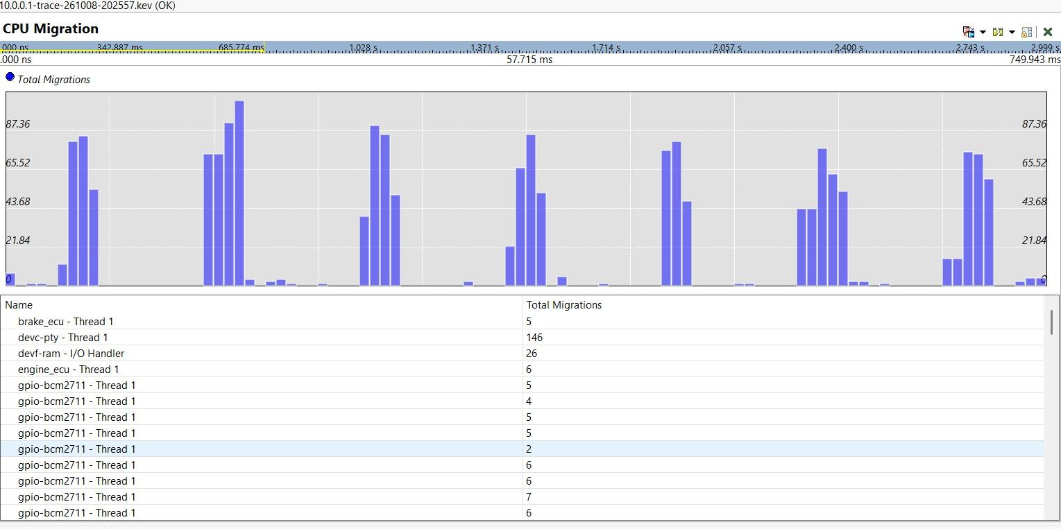
Figure 15.7. QNX System Profiler CPU Migration view showing recorded thread migration counts.

What it shows
The CPU Migration view displays migration counts for selected threads:
- devc-pty - Thread 1: 146 migrations
- devf-ram - I/O Handler: 26 migrations
- engine_ecu - Thread 1: 6 migrations
- brake_ecu - Thread 1: 5 migrations
These values are the counts displayed in the captured profiler view.

What it means
The recorded migration counts indicate that the listed threads migrated between CPU cores during the trace interval. This information can be used to investigate thread placement and multicore scheduling behavior.
The engine_ecu and brake_ecu thread entries show six and five migrations, respectively, in the captured view. These counts do not measure migration duration or prove that migration caused additional latency. Controlled profiling would be required to evaluate the impact of CPU migration on ECU response time.

15.8 Inter-CPU Communication Analysis
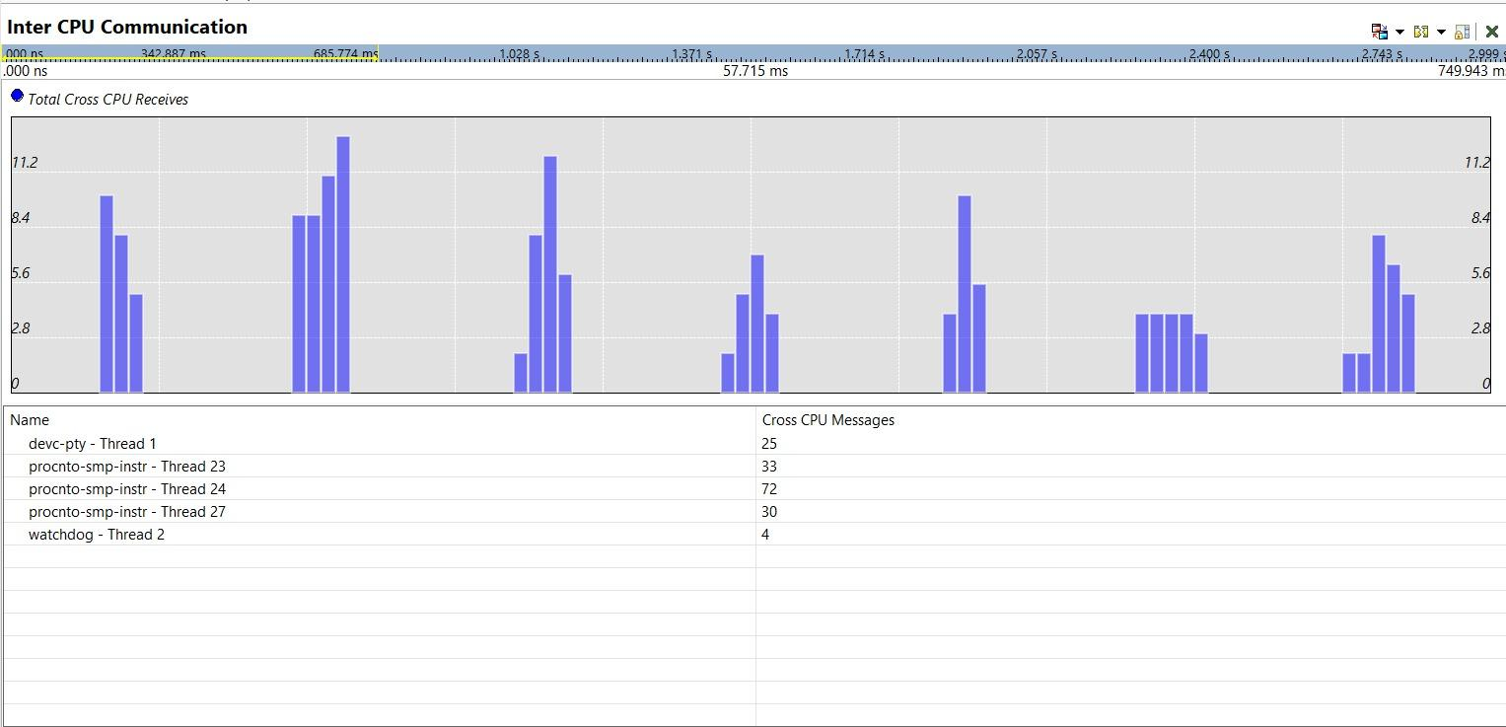
Figure 15.8. QNX System Profiler Inter-CPU Communication view showing cross-CPU receive counts for selected threads.

What it shows
The Inter-CPU Communication view displays the following cross-CPU message counts:
- procnto-smp-instr - Thread 24: 72 messages
- procnto-smp-instr - Thread 23: 33 messages
- procnto-smp-instr - Thread 27: 30 messages
- devc-pty - Thread 1: 25 messages
- watchdog - Thread 2: 4 messages
These are the values displayed in the profiler's cross-CPU communication summary.

What it means
The observations establish that cross-CPU communication events were recorded for the listed system and Watchdog threads during the trace interval.
The counts provide insight into multicore communication activity but do not directly measure IPC latency or identify the complete communication path of each ECU heartbeat. They also do not establish that every cross-CPU event originated from QNX Sentinel application-level message passing.

15.9 Runtime Heartbeat and Fault Analysis
The System Profiler observations complement the application-level heartbeat and recovery logs collected during testing.

What it shows
The recorded runtime evidence includes:
- Normal operation: Heartbeat messages from Engine, Brake, and Steering ECU services.
- Engine heartbeat failure: A missed-heartbeat interval of 1012 ms, followed by watchdog detection and recovery activity.
- Engine recovery output: ENGINE ECU RECOVERED SUCCESSFULLY displayed in the runtime output.
- Brake deadlock: A missed-heartbeat interval of 1024 ms, followed by deadlock-related detection and recovery activity.
- Brake process restart: A new Brake ECU process ID displayed during the restart sequence.
- Other ECU services: Heartbeat messages remained visible in the recorded Engine and Brake fault-handling output.

What it means
The runtime logs show that the framework detected the demonstrated Engine and Brake fault conditions and initiated recovery activity. The continued visibility of other ECU heartbeat messages supports the selective-recovery objective during the observed periods.
The missed-heartbeat intervals of 1012 ms and 1024 ms are not total recovery times. The runtime logs and profiler screenshots do not, by themselves, establish exact fault-detection latency or prove uninterrupted service throughout every recovery operation.

15.10 Trace Scope and Limitations
The available evidence includes the System Summary, process-monitoring screenshot, application runtime logs, and QNX System Profiler trace views.
The detailed profiler views display a trace interval of approximately 749.943 ms. Therefore, the profiler measurements in this section describe the captured interval and should not be generalized to long-duration operation.
The current evidence supports observations of:
- Target configuration and system resources.
- ECU and supporting-process visibility.
- CPU execution-time values and CPU activity.
- Process and thread timelines.
- CPU migration counts.
- Inter-CPU communication counts.
- Runtime heartbeat detection and recovery messages.
However, the available measurements do not independently establish:
- Worst-case execution time or scheduling latency.
- Guaranteed real-time deadline compliance.
- The performance cost of individual CPU migrations.
- Complete fault-detection latency or total recovery duration.
- Long-duration CPU utilization or memory stability.
- The communication latency of individual ECU heartbeat messages.
These performance metrics require additional event-level analysis, paired runtime timestamps, or controlled measurements.

15.11 System Monitoring Summary
The QNX Momentics screenshots document a Raspberry Pi 4B running QNX 8.0.0 with four AArch64 CPU cores, 4032 MB of total memory, and 37 processes in the captured System Summary. The process-monitoring view lists the ECU services and supporting QNX Sentinel components with their displayed process and resource information.
The System Profiler trace adds execution-level observations, including a displayed CPU usage summary of 92.246 ms, per-core CPU values, CPU activity across four cores, thread timelines, migration counts, and cross-CPU message counts.
Combined with the runtime logs, these observations provide evidence of the project components running in the target environment and responding to the demonstrated Engine and Brake fault scenarios. The trace analysis improves visibility into the execution environment, while exact scheduling latency, deadline guarantees, and total fault-detection and recovery times remain separate performance measurements requiring additional evidence.
The QNX System Profiler analysis combines system configuration, process monitoring, kernel-trace observations, and runtime fault-handling evidence to evaluate the QNX Sentinel framework. The captured measurements document CPU execution time, multicore activity, thread timelines, CPU migration, and inter-CPU communication during the recorded session.
The analysis supports the conclusion that the ECU services and supporting components were active in the monitored QNX environment and that the captured trace contains measurable multicore execution activity. It does not establish unmeasured real-time guarantees or exact recovery latency. These limitations are retained to ensure that the report distinguishes recorded evidence from performance metrics that still require dedicated measurement.

16. TESTING AND VALIDATION
Testing and validation were conducted to evaluate the QNX Sentinel – Automotive ECU Watchdog and Recovery Framework on a Raspberry Pi 4B running QNX 8.0.0. The evaluation covered normal ECU heartbeat monitoring, fault injection, watchdog detection, recovery activity, process monitoring, QNX System Profiler trace analysis, and GPIO-based hardware status indication.
The validation combines application runtime logs, QNX Momentics System Summary and process-monitoring screenshots, System Profiler trace views, and physical hardware observations. The results are reported according to the behavior observed during the performed tests.

16.1 Test Scenarios and Coverage
The framework was evaluated using functional tests, runtime observations, system monitoring, profiler trace analysis, and physical hardware validation.
Table 16.1. Test scenarios and validation coverage.
Test ID | Test scenario | Component under test | Validation method | Status
T01 | Normal heartbeat monitoring | Engine, Brake, Steering ECUs | Inspect runtime heartbeat messages | Verified
T02 | Engine heartbeat failure | Engine ECU and Watchdog | Inject heartbeat failure and inspect detection logs | Verified
T03 | Engine recovery | Recovery Manager and Engine ECU | Inspect recovery output | Verified
T04 | Brake deadlock | Brake ECU and Watchdog | Inject deadlock scenario and inspect detection logs | Verified
T05 | Brake process restart | Recovery Manager and Brake ECU | Inspect recovery logs and process ID | Verified
T06 | Steering execution overrun | Steering ECU | Trigger configured overrun and observe runtime behavior | Verified
T07 | System configuration monitoring | Raspberry Pi 4B and QNX 8.0.0 | Inspect Momentics System Summary | Verified
T08 | Process monitoring | ECU and supporting processes | Inspect Momentics process-monitoring view | Verified
T09 | CPU usage analysis | QNX System Profiler | Inspect CPU Usage view | Verified
T10 | CPU activity analysis | Four CPU cores | Inspect CPU Activity view | Verified
T11 | Process and thread timeline analysis | ECU and supporting processes | Inspect System Profiler timelines | Verified
T12 | CPU migration analysis | Selected system and ECU threads | Inspect CPU Migration view | Verified
T13 | Inter-CPU communication analysis | Selected system and Watchdog threads | Inspect Inter-CPU Communication view | Verified
T14 | GPIO hardware status indication | Nine LED outputs | Observe LED transitions during ECU execution and state changes | Verified
Note: “Verified” means the corresponding behavior or view was observed in the performed test or supplied evidence. It does not imply exhaustive testing or a quantitative performance guarantee.

16.2 Engine ECU Heartbeat-Failure Validation
The Engine ECU heartbeat-failure test evaluates the watchdog response when the Engine ECU stops producing its expected heartbeat messages.

Test procedure
- Start the QNX Sentinel components and ECU services.
- Open the Fault Injector.
- Select option 1 to inject the Engine ECU heartbeat-failure fault.
- Observe the missing-heartbeat detection messages.
- Inspect the recovery manager's response and resulting recovery logs.

Observed result
The runtime output displayed an Engine ECU missed-heartbeat interval of 1012 ms. The watchdog subsequently reported failure detection and recovery activity. The log displayed:
ENGINE ECU RECOVERED SUCCESSFULLY

Technical interpretation
The recorded output verifies that the demonstrated Engine heartbeat-failure scenario was detected and that the application reported a successful recovery outcome.
The 1012 ms value is the missed-heartbeat interval displayed in the runtime log. It is not the complete fault-detection latency or total recovery duration because the fault-injection, detection, and recovery-completion timestamps were not recorded as a measured sequence.

16.3 Brake ECU Deadlock Validation
The Brake ECU deadlock test evaluates the framework's response to the configured deadlock-related fault scenario.

Test procedure
- Start the QNX Sentinel components and ECU services.
- Open the Fault Injector.
- Select option 2 to trigger the Brake ECU deadlock scenario.
- Observe the Brake ECU heartbeat output.
- Inspect the detection and recovery logs.
- Observe the Brake ECU process ID displayed during the restart sequence.

Observed result
The runtime output displayed a Brake ECU missed-heartbeat interval of 1024 ms, followed by deadlock-related detection and recovery activity. A new Brake ECU process ID was displayed during the restart sequence.

Technical interpretation
The recorded logs verify that the simulated Brake ECU fault was associated with missing-heartbeat detection and process-restart activity.
The new process ID indicates that a new Brake ECU process instance was started during recovery. However, the process ID alone does not establish the duration of the restart or prove sustained service restoration over an extended period.

16.4 Steering ECU Execution-Overrun Validation
The Steering ECU execution-overrun test evaluates the framework's behavior when the steering-control task experiences the configured execution delay.

Test procedure
- Start the QNX Sentinel components and ECU services.
- Open the Fault Injector.
- Select option 3 to trigger the Steering ECU execution-overrun scenario.
- Observe the Steering ECU execution behavior and runtime response.
- Verify the execution-overrun test result.

Observed result
The Steering ECU execution-overrun test was completed and verified. The configured overrun scenario was triggered, and its execution behavior was observed during testing.

Technical interpretation
The test verifies the configured execution-overrun scenario and its observed runtime behavior. The Steering ECU implementation includes execution-time measurement and task-completion messaging, which provide mechanisms for examining task execution.
Exact overrun-detection latency, deadline compliance, and total recovery duration were not established through timestamped measurements.

16.5 QNX Momentics System and Process Monitoring
QNX Momentics was used to inspect the target configuration and project processes during the captured session.
The System Summary displayed:
- Target board: RaspberryPi4B.
- QNX version: 8.0.0.
- CPU architecture: AArch64.
- CPU cores: 4.
- Displayed CPU frequency: 1500 MHz.
- Total memory: 4032 MB.
- Used memory: 327 MB.
- Free memory: 3704 MB.
- Total processes: 37.
The process-monitoring view displayed the following CPU-usage readings:
- ecu_launcher — PID 335897: 2 ms.
- recovery_manager — PID 339994: 4 ms.
- watchdog — PID 339995: 567 ms.
- fault_injector — PID 12673060: 1 ms.
- engine_ecu — PID 42328102: 6 ms.
- steering_ecu — PID 49836073: 5 ms.
- brake_ecu — PID 51669987: 2 ms.
These are values displayed in the captured process-monitoring view. They are in milliseconds rather than percentages, and the sampling interval was not established. They should not be interpreted as sustained CPU-utilization measurements.

16.6 QNX System Profiler Trace Validation
The captured QNX System Profiler .kev trace was examined using the CPU Usage, CPU Activity, Timeline, CPU Migration, and Inter-CPU Communication views.

CPU Usage
The profiler summary displayed a total CPU usage value of 92.246 ms, distributed as follows:
- CPU 0: 37.286 ms.
- CPU 1: 31.555 ms.
- CPU 2: 17.754 ms.
- CPU 3: 5.649 ms.
These values represent the displayed execution-time summary and are not CPU-utilization percentages.

CPU Activity
The CPU Activity view displayed changing activity across CPU 0, CPU 1, CPU 2, and CPU 3. Repeated activity peaks were visible during the captured interval.
This verifies that the trace contains CPU activity information across the four cores. The graph alone does not establish sustained utilization or worst-case CPU load.

Process and Thread Timeline
The timeline views displayed execution activity for engine_ecu, brake_ecu, steering_ecu, watchdog, recovery_manager, fault_injector, and ecu_launcher.
This provides evidence of recorded process and thread activity during the captured interval. It does not independently prove deadline compliance or establish exact scheduling latency.

CPU Migration
The CPU Migration view displayed the following counts:
- devc-pty - Thread 1: 146 migrations.
- devf-ram - I/O Handler: 26 migrations.
- engine_ecu - Thread 1: 6 migrations.
- brake_ecu - Thread 1: 5 migrations.
These counts confirm that migration events were recorded for the listed threads. They do not measure the time cost of migration.

Inter-CPU Communication
The Inter-CPU Communication view displayed:
- procnto-smp-instr - Thread 24: 72 cross-CPU messages.
- procnto-smp-instr - Thread 23: 33 cross-CPU messages.
- procnto-smp-instr - Thread 27: 30 cross-CPU messages.
- devc-pty - Thread 1: 25 cross-CPU messages.
- watchdog - Thread 2: 4 cross-CPU messages.
These values verify that cross-CPU communication events were recorded for the listed threads. They do not directly measure application-level IPC latency or identify the complete communication path of each ECU heartbeat.
The detailed profiler views display an interval of approximately 749.943 ms. The recorded measurements therefore describe the captured trace interval rather than a long-duration performance test.

16.7 GPIO Hardware Validation
GPIO hardware validation was performed using the Raspberry Pi 4B and the nine-LED status indication arrangement. Three LEDs were assigned to each ECU service.
The status convention is:
- Green: ECU operating in the healthy state.
- Yellow: ECU recovery in progress.
- Red: ECU in the failed state.
The GPIO assignments are:
- Engine ECU: GPIO 17 — Green; GPIO 27 — Yellow; GPIO 22 — Red.
- Brake ECU: GPIO 23 — Green; GPIO 24 — Yellow; GPIO 25 — Red.
- Steering ECU: GPIO 5 — Green; GPIO 6 — Yellow; GPIO 12 — Red.

Observed result
All nine LEDs were tested and verified to change their lighting according to the corresponding ECU execution states.

Technical interpretation
The observed LED transitions verify the physical status-indication behavior during the performed tests. The nine-LED arrangement provides a visual representation of the Engine, Brake, and Steering ECU states.
The validation confirms the observed LED response but does not establish numerical GPIO update latency or guarantee correct indication under every possible fault condition.

16.8 Validation Limitations
Although the functional tests and profiler views provide evidence of the framework's behavior, some performance measurements remain outside the scope of the captured evidence.
- Fault-detection latency: The complete interval between fault injection and watchdog detection was not calculated from paired timestamps.
- Total recovery duration: The complete time from fault detection to confirmed service restoration was not measured.
- Recovery success rate: A consolidated count of total trials and successful recovery trials was not available for calculating a numerical success rate.
- Scheduling latency: The captured profiler views do not establish a quantitative scheduling-latency result.
- Long-duration resource utilization: The Momentics screenshots represent captured observations rather than long-duration CPU and memory measurements.
- GPIO response latency: The LED state changes were verified, but the delay between a software state transition and the corresponding physical LED transition was not measured.
These limitations distinguish functional validation from quantitative performance characterization.

16.9 Validation Summary
The performed tests and captured evidence support the following conclusions:
- Normal heartbeat activity was observed for all three ECU services.
- Engine heartbeat-failure detection and the application's recovery-success output were verified.
- Brake deadlock-related detection and process-restart activity were verified.
- The Steering ECU execution-overrun test was completed and verified.
- QNX Momentics displayed the target configuration and project process information.
- The System Profiler trace contained CPU Usage, CPU Activity, Timeline, CPU Migration, and Inter-CPU Communication views.
- All nine GPIO-connected LEDs were verified to change according to the corresponding ECU execution states.
The results demonstrate the observed functional behavior of the QNX Sentinel framework on the Raspberry Pi 4B running QNX 8.0.0. The numerical profiler values provide evidence of recorded CPU activity, migration events, and cross-CPU communication during the captured interval.
The testing and validation activities demonstrate the observed operation of QNX Sentinel across ECU heartbeat monitoring, simulated fault injection, recovery activity, process monitoring, kernel-trace analysis, and physical GPIO status indication.
The Engine and Brake fault scenarios produced recorded missed-heartbeat intervals of 1012 ms and 1024 ms, respectively. The Steering execution-overrun test was verified, and all nine GPIO-connected LEDs were confirmed to change according to the corresponding ECU execution states.

17. RESULTS

17.1 Successfully Demonstrated
The QNX Sentinel – Automotive ECU Watchdog and Recovery Framework was implemented and tested on a Raspberry Pi 4B running QNX 8.0.0. The system was designed to monitor three ECU services—Engine, Brake, and Steering—and demonstrate fault detection, selective recovery, process monitoring, and GPIO-based status indication.
The following outcomes were demonstrated during implementation and testing:
- Normal ECU operation: Engine, Brake, and Steering heartbeat messages were observed during normal execution.
- Engine ECU fault detection: The runtime logs recorded a missed-heartbeat interval of 1012 ms, followed by watchdog fault detection and recovery-manager activity.
- Engine ECU recovery: The runtime output displayed the message “ENGINE ECU RECOVERED SUCCESSFULLY,” providing evidence that the Engine ECU recovery path executed.
- Brake ECU fault handling: The runtime logs recorded a missed-heartbeat interval of 1024 ms. The recovery manager initiated the Brake ECU restart, and a new Brake ECU process identifier was observed.
- Steering ECU execution-overrun testing: The Steering execution-overrun fault-injection scenario was tested, and its execution was verified during project validation. A numerical overrun duration or recovery time was not recorded.
- GPIO status indication: All nine LEDs were tested and verified to change according to their corresponding ECU execution states.
These results demonstrate the implementation of the primary monitoring and fault-handling workflows. They do not, by themselves, establish automotive-grade reliability or compliance with real-time safety requirements.

17.2 Measured Runtime and Platform Results
The project was executed on the following target configuration:
- Hardware platform: Raspberry Pi 4B
- Operating system: QNX 8.0.0
- Processor architecture: AArch64
- CPU cores: 4
- Displayed CPU frequency: 1500 MHz
- Total memory: 4032 MB
- Used memory: 327 MB
- Free memory: 3704 MB
- Total processes shown in System Summary: 37
The QNX Momentics System Summary and process-monitoring views provided information about the running system and the ECU-related processes. These values represent the captured monitoring snapshot and should not be interpreted as long-duration resource-utilization measurements.
The recorded missed-heartbeat intervals were:
- Engine ECU: 1012 ms
- Brake ECU: 1024 ms
These values represent the intervals reported in the runtime logs around missed-heartbeat detection. They are not measurements of the complete fault-detection latency or total recovery duration.

17.3 QNX System Profiler Results
QNX System Profiler screenshots were used to examine CPU usage, CPU activity, process and thread timelines, CPU migration, and inter-CPU communication.

17.3.1 CPU Usage
The captured CPU Usage view displayed a summary of 92.246 ms, with the following per-core values:
- CPU 0: 37.286 ms
- CPU 1: 31.555 ms
- CPU 2: 17.754 ms
- CPU 3: 5.649 ms
These values describe the displayed CPU usage measurements for the captured trace. They are time values in milliseconds, not CPU utilization percentages. They should not be generalized to the entire execution period or used as evidence of sustained processor utilization.

17.3.2 CPU Activity and Process Timeline
The CPU Activity views showed activity across the four CPU cores. The process and thread timeline included ECU-related processes such as engine_ecu, brake_ecu, and steering_ecu, along with watchdog, recovery_manager, fault_injector, and other system processes.
These views provided visibility into the observed execution activity and process presence during the captured interval. The screenshots do not independently establish deadline compliance, worst-case execution time, or scheduling latency.

17.3.3 CPU Migration
The captured CPU Migration view reported the following migration counts:
- devc-pty – Thread 1: 146
- devf-ram – I/O Handler: 26
- engine_ecu – Thread 1: 6
- brake_ecu – Thread 1: 5
These counts indicate observed thread migrations in the trace. They do not directly measure migration overhead or demonstrate a performance improvement.

17.3.4 Inter-CPU Communication
The Inter-CPU Communication view displayed the following counts:
- procnto-smp-instr – Thread 24: 72
- procnto-smp-instr – Thread 23: 33
- procnto-smp-instr – Thread 27: 30
- devc-pty – Thread 1: 25
- watchdog – Thread 2: 4
These are the counts shown in the captured profiler view. They are not application-level IPC latency measurements, and they should not be interpreted as counts of ECU heartbeat messages alone.
The detailed profiler views showed a trace interval of approximately 749.943 ms. The observations therefore apply to that captured interval rather than representing a complete long-duration performance evaluation.

17.4 Process Monitoring Results
The QNX Momentics process-monitoring screenshot displayed the following ECU-related and supporting processes:
- ecu_launcher — PID 335897
- recovery_manager — PID 339994
- watchdog — PID 339995
- fault_injector — PID 12673060
- engine_ecu — PID 42328102
- steering_ecu — PID 49836073
- brake_ecu — PID 51669987
The screenshot also displayed CPU-time values for these processes. Since the measurement interval and precise interpretation of the displayed CPU-time column were not established, the values are treated as a monitoring snapshot rather than comparative CPU utilization percentages.
The runtime logs and process-monitoring evidence together support the observation that the framework and its associated ECU processes were active during testing. The Brake ECU restart was also observed through a changed process identifier in the fault-handling output.

17.5 Hardware Integration Results
The framework was integrated with a Raspberry Pi 4B and a breadboard containing nine LEDs for ECU status indication.
The LED assignments were configured as follows:
- Engine ECU: Green GPIO 17, Yellow GPIO 27, Red GPIO 22
- Brake ECU: Green GPIO 23, Yellow GPIO 24, Red GPIO 25
- Steering ECU: Green GPIO 5, Yellow GPIO 6, Red GPIO 12
Green represents the healthy state, yellow represents recovery, and red represents failure. During hardware validation, all nine LEDs were tested, and their state changes were verified against the corresponding ECU execution states.
This confirms the tested GPIO status-indication functionality. It does not establish the electrical or functional safety of a production automotive interface.

17.6 Results Not Quantified
Although the main fault-injection and monitoring workflows were demonstrated, several performance metrics were not measured quantitatively. These include:
- Exact fault-detection latency from fault initiation to detection.
- Total recovery duration from detection to confirmed service restoration.
- Worst-case recovery time across repeated trials.
- Steering execution-overrun duration and its precise effect on watchdog decisions.
- Long-duration stability and recovery success rate across a statistically meaningful number of tests.
- Worst-case execution time, scheduling latency, and deadline-miss statistics.
The available screenshots and runtime logs should therefore be used as evidence of observed execution and functionality, not as proof of these unmeasured properties.

17.7 Overall Result Summary
The QNX Sentinel prototype demonstrated the principal functions of the project: concurrent monitoring of three ECU services, heartbeat-based fault observation, Engine ECU recovery activity, Brake ECU restart activity, Steering execution-overrun testing, process-level monitoring, QNX System Profiler analysis, and GPIO-based status indication.
The collected runtime logs, Momentics screenshots, profiler views, and hardware tests provide evidence of the implementation and its observed behavior. Further repeated testing and quantitative timing measurements are required to evaluate recovery consistency, real-time performance, and long-duration reliability.

Conclusion
The results show that the QNX Sentinel prototype successfully demonstrated its intended monitoring, fault-injection, recovery, and hardware-indication workflows on a Raspberry Pi 4B running QNX 8.0.0. The profiler data provides additional insight into CPU activity, process timelines, migration counts, and inter-CPU communication during the captured trace.

18. LIMITATIONS
Although the QNX Sentinel – Automotive ECU Watchdog and Recovery Framework successfully demonstrated ECU heartbeat monitoring, fault injection, recovery workflows, process monitoring, and GPIO-based status indication, certain limitations remain. These limitations identify the current scope of the prototype and the areas that require further testing before it can be considered for deployment in a real automotive environment.

18.1 Limited Fault Coverage
The current prototype focuses on three ECU services: Engine, Brake, and Steering. The implemented fault-injection scenarios cover Engine heartbeat failure, Brake ECU deadlock simulation, and Steering execution overrun.
These scenarios demonstrate selected failure conditions but do not represent the complete range of faults that may occur in automotive electronic control units. Additional scenarios, such as communication failures, resource exhaustion, intermittent faults, and repeated service failures, require further implementation and validation.

18.2 Fault-Detection Timing Limitations
The runtime logs recorded missed-heartbeat intervals of 1012 ms for the Engine ECU and 1024 ms for the Brake ECU. These values describe the intervals reported during the observed fault-handling tests.
The exact fault-detection latency, measured from the moment a fault is injected until the watchdog declares the fault, was not independently recorded. Consequently, the current results do not establish a precise detection-latency bound or prove that all faults will be detected within a fixed deadline.

18.3 Recovery-Time Measurement
The Engine ECU runtime output displayed a successful recovery message, while the Brake ECU fault-handling output showed the recovery manager initiating a restart and a new Brake ECU process identifier.
However, the total recovery duration—from fault occurrence through detection, recovery initiation, process restart, and confirmed restoration of service—was not measured quantitatively. Repeated trials are required to evaluate recovery consistency and establish recovery-time statistics.

18.4 Steering Execution-Overrun Validation
The Steering execution-overrun scenario was tested and verified during project validation. However, a numerical execution-overrun duration and a complete timing analysis of its effect on watchdog decisions were not recorded.
The Steering service also contains separate execution and heartbeat activities. Therefore, a task overrun should not automatically be interpreted as a complete process failure or a missed heartbeat without supporting runtime evidence. Further testing is needed to establish how different overrun durations affect detection and recovery behavior.

18.5 Recovery Reliability and Repeated Testing
The available runtime evidence demonstrates the observed Engine and Brake fault-handling workflows. However, a statistically meaningful set of repeated trials has not been documented for every fault scenario.
The project therefore does not establish a numerical recovery success rate, false-positive rate, or probability of successful recovery under repeated or simultaneous faults. Repeated tests under controlled conditions are necessary to evaluate these properties.

18.6 CPU and System Resource Analysis
QNX Momentics System Summary and process-monitoring views provided information about the target platform, memory, running processes, and displayed CPU-time values. QNX System Profiler also provided CPU usage, CPU activity, process timelines, CPU migration counts, and inter-CPU communication observations.
These measurements are limited to the captured monitoring snapshots and trace interval. They do not establish long-duration CPU utilization, worst-case execution time, scheduling latency, or the resource overhead of the framework under sustained or heavy workloads.
The CPU migration and inter-CPU communication counts also cannot independently quantify migration overhead or application-level IPC latency.

18.7 Real-Time Scheduling Verification
The framework was implemented and tested on QNX, and the available profiler views show process and thread execution activity. However, the collected evidence does not provide a complete quantitative evaluation of thread priorities, worst-case scheduling latency, deadline compliance, or deadline-miss frequency.
Consequently, the prototype's real-time behavior has not been fully characterized under worst-case operating conditions. Additional trace analysis and controlled timing experiments are required before making stronger real-time performance claims.

18.8 Hardware Integration Scope
The hardware implementation uses a Raspberry Pi 4B and nine GPIO-connected LEDs to indicate the states of the Engine, Brake, and Steering ECU services. All nine LEDs were tested and verified to change according to their corresponding ECU execution states.
This arrangement provides a visual demonstration of status indication, but it is not a complete automotive hardware interface. The current implementation does not establish compatibility with production ECU communication networks, such as CAN, or validate automotive electrical, environmental, and functional-safety requirements.
Appropriate current-limiting resistors and suitable electrical protection must also be used when connecting LEDs to GPIO pins.

18.9 Limited Long-Duration and Stress Testing
The available results demonstrate selected normal-operation and fault-injection scenarios. They do not establish stability over extended operating periods or under high process loads, repeated recovery cycles, and multiple simultaneous failures.
Long-duration execution, controlled stress tests, and repeated fault injection are necessary to identify resource leaks, recovery loops, unexpected process termination, and other issues that may not appear during short demonstrations.

18.10 Automotive Deployment and Safety Limitations
QNX Sentinel is a prototype intended to demonstrate monitoring and recovery concepts. It has not been established as a production-ready automotive safety system.
Before deployment in an actual vehicle, further engineering and validation would be required, including safety analysis, failure-mode assessment, communication-interface integration, timing verification, fault-containment testing, and evaluation against applicable automotive standards and development processes.
The successful execution of selected fault-injection tests does not, by itself, demonstrate compliance with automotive functional-safety requirements.

Conclusion
The principal limitations of QNX Sentinel concern incomplete quantitative timing measurements, limited fault coverage, the need for repeated recovery trials, and the scope of hardware and real-time validation. The prototype demonstrates its core monitoring and fault-handling workflows, but additional systematic testing is required to establish recovery reliability, worst-case timing behavior, long-duration stability, and suitability for more demanding automotive applications.

19. FUTURE WORK
The QNX Sentinel – Automotive ECU Watchdog and Recovery Framework demonstrates heartbeat-based monitoring, fault injection, selective ECU recovery workflows, process monitoring, and GPIO-based status indication. The following enhancements can extend the prototype, improve its evaluation, and support further investigation of its suitability for automotive applications.

19.1 Quantitative Fault-Detection Timing
Future work will focus on measuring the exact fault-detection latency for each ECU service. The measurement will begin at the moment a fault is injected and end when the watchdog identifies the fault.
Separate measurements will be collected for Engine heartbeat failure, Brake deadlock, and Steering execution overrun. Repeated trials will help calculate average, minimum, maximum, and variation in detection time. This will provide a more complete evaluation than missed-heartbeat intervals alone.

19.2 Recovery-Time Measurement
The recovery process can be evaluated by recording timestamps at fault occurrence, fault detection, recovery initiation, process restart, and confirmed service restoration.
These measurements will help determine the total recovery duration and identify which stages contribute most to the recovery process. Repeated testing will also help assess the consistency of recovery behavior across different fault scenarios.

19.3 Expanded Fault-Injection Scenarios
The existing fault injector can be extended to cover additional failure conditions, including intermittent heartbeat loss, repeated service failures, communication errors, and selected resource-exhaustion scenarios.
Further testing can investigate whether the watchdog distinguishes temporary interruptions from persistent failures and whether the recovery manager responds appropriately. Simultaneous faults affecting multiple ECU services can also be evaluated to examine fault isolation and recovery behavior.

19.4 Enhanced Steering Overrun Analysis
The Steering ECU execution-overrun scenario can be extended with configurable overrun durations and repeated measurements. Execution time, heartbeat behavior, task-completion messages, and watchdog responses can be recorded for each test.
This work would help establish the relationship between execution overruns and fault-detection decisions. It would also help determine whether additional monitoring is needed to distinguish a delayed task from a complete ECU service failure.

19.5 Advanced QNX System Profiler Analysis
Future testing can use longer and repeated QNX System Profiler traces to examine CPU activity, process and thread execution timelines, CPU migration, and inter-CPU communication under different workloads.
The analysis can be expanded to include controlled measurements of scheduling latency, execution-time variation, resource overhead, and deadline behavior where suitable instrumentation is available. CPU usage should be reported with the measurement interval and units clearly specified.

19.6 Long-Duration Stability and Stress Testing
The framework can be evaluated during extended execution to examine its stability under continuous heartbeat monitoring and repeated fault-recovery cycles.
Stress testing can investigate CPU and memory behavior, unexpected process termination, repeated recovery attempts, and possible resource leaks. The results can be compared across different workload levels and fault-injection frequencies.

19.7 Improved Recovery Verification
Future versions can include an explicit post-recovery health check for every ECU service. Rather than relying only on process restart or a recovery log message, the framework can verify that the restarted service is responding correctly and producing valid heartbeat messages.
Recovery status can be recorded separately as recovery initiated, process restarted, and service restored. This distinction would improve the accuracy of recovery-success measurements.

19.8 Enhanced Hardware Integration
The existing nine-LED GPIO interface can be extended with clearer fault-state indication and additional diagnostic outputs. The software can also be improved to ensure that LED states remain synchronized with the latest verified ECU status during recovery and repeated failures.
Further hardware development could investigate integration with automotive communication interfaces such as CAN, subject to suitable hardware and software support. Such integration would require additional protocol, electrical-interface, and fault-handling validation.

19.9 Automated Test Logging and Reporting
An automated testing module can be developed to record fault-injection events, timestamps, watchdog decisions, recovery actions, process identifiers, and post-recovery health-check results.
The collected information could be used to generate structured test reports containing detection latency, recovery duration, trial counts, and recovery success rates. Automated reporting would make it easier to compare test runs and identify regressions after software modifications.

19.10 Evaluation on Automotive-Oriented Hardware
The current prototype uses a Raspberry Pi 4B running QNX 8.0.0. Future work can investigate deployment on an appropriate automotive-oriented hardware platform, subject to operating-system support and hardware availability.
Such an evaluation would require additional testing of processor performance, communication interfaces, resource constraints, fault containment, and recovery behavior under representative operating conditions.

19.11 Safety and Reliability Validation
Before considering real automotive deployment, the framework would require a more extensive safety and reliability evaluation. This could include systematic failure-mode analysis, fault-containment testing, recovery-path verification, and assessment against applicable automotive functional-safety requirements.
The objective would be to determine the limitations of the current design and identify the additional engineering controls and evidence required for safety-critical use.
Future development of QNX Sentinel will focus on quantitative timing measurements, improved recovery verification, expanded fault injection, longer-duration testing, and deeper QNX System Profiler analysis. Enhancements to hardware integration and automated reporting can further improve observability and test repeatability. These activities would provide stronger evidence of system reliability and help determine the framework's suitability for more demanding automotive monitoring and recovery applications.

20. CONCLUSION
The QNX Sentinel – Automotive ECU Watchdog and Recovery Framework was developed to demonstrate heartbeat-based monitoring, fault detection, and selective recovery of automotive Electronic Control Unit (ECU) services using QNX Neutrino RTOS. The prototype was implemented on a Raspberry Pi 4B running QNX 8.0.0 and included three ECU services: Engine, Brake, and Steering.
The framework demonstrated normal heartbeat communication and selected fault-injection scenarios. During Engine ECU fault testing, the runtime logs recorded a missed-heartbeat interval of 1012 ms, followed by watchdog detection and recovery-manager activity. The runtime output also displayed an Engine ECU recovery success message. During Brake ECU fault testing, a missed-heartbeat interval of 1024 ms was recorded, and the recovery manager initiated a restart that was accompanied by a new Brake ECU process identifier. The Steering execution-overrun scenario was also tested and verified.
QNX Momentics System Summary, process monitoring, and System Profiler views were used to examine the target configuration, running processes, CPU usage, CPU activity, process and thread timelines, CPU migration, and inter-CPU communication. In addition, hardware integration was demonstrated using nine GPIO-connected LEDs to indicate the execution states of the three ECU services. All nine LEDs were tested and verified to change according to their corresponding ECU execution states.
The results demonstrate the feasibility of combining ECU heartbeat monitoring, fault injection, recovery workflows, runtime observation, and hardware status indication in a QNX-based prototype. However, exact fault-detection latency, total recovery duration, worst-case timing behavior, and long-duration recovery reliability remain to be measured through further controlled testing.
In conclusion, QNX Sentinel provides a practical foundation for exploring fault monitoring and selective service recovery in automotive-oriented real-time systems. Future enhancements will focus on quantitative timing analysis, expanded fault coverage, automated test reporting, improved post-recovery health verification, and more extensive reliability testing before considering deployment in a production automotive environment.

21. APPENDIX
This appendix provides supporting technical information for the QNX Sentinel – Automotive ECU Watchdog and Recovery Framework, including the target platform, ECU status indication, fault-injection options, and validation evidence collected during implementation and testing.

21.1 Hardware and Software Configuration
The prototype was implemented using the following configuration:
- Target hardware: Raspberry Pi 4B
- Operating system: QNX 8.0.0
- Processor architecture: AArch64
- CPU cores: 4
- Displayed CPU frequency: 1500 MHz
- Total memory: 4032 MB
- Used memory: 327 MB
- Free memory: 3704 MB
- Development and monitoring environment: QNX Momentics and QNX System Profiler

21.2 ECU Services
The framework includes three ECU services:
- Engine ECU: Sends heartbeat messages and supports heartbeat-failure fault injection.
- Brake ECU: Sends heartbeat messages and supports deadlock-related fault simulation.
- Steering ECU: Sends heartbeat messages and includes an execution-overrun test scenario.
The watchdog and recovery components monitor ECU activity and participate in the demonstrated fault-handling workflows.

21.3 GPIO Pin Mapping
Nine LEDs were connected to Raspberry Pi GPIO pins to provide visual status indication for the three ECU services.
- Engine ECU: GPIO 17 — Green; GPIO 27 — Yellow; GPIO 22 — Red.
- Brake ECU: GPIO 23 — Green; GPIO 24 — Yellow; GPIO 25 — Red.
- Steering ECU: GPIO 5 — Green; GPIO 6 — Yellow; GPIO 12 — Red.
The configured indications are green for healthy operation, yellow for recovery, and red for failure. All nine LEDs were tested and verified to change according to their corresponding ECU execution states.
Current-limiting resistors and appropriate electrical precautions must be used when connecting LEDs to GPIO pins.

21.4 Fault-Injection Options
The fault injector provides the following command-line test scenarios:
- Option 1 – Engine heartbeat failure: Disables the Engine ECU heartbeat activity to exercise missed-heartbeat detection.
- Option 2 – Brake deadlock: Simulates a deadlock-related condition in the Brake ECU.
- Option 3 – Steering execution overrun: Exercises the Steering ECU execution-overrun scenario.
- Option q – Quit: Exits the fault-injector interface.
These options were used to exercise the corresponding fault-handling workflows during project validation.

21.5 Runtime Evidence
The following evidence was collected during implementation and testing:
- Normal-operation terminal output showing heartbeat messages from the Engine, Brake, and Steering ECU services.
- Fault-injector terminal output showing the available fault-injection options.
- Engine ECU runtime logs showing a missed-heartbeat interval of 1012 ms, watchdog detection, recovery activity, and an Engine ECU recovery success message.
- Brake ECU runtime logs showing a missed-heartbeat interval of 1024 ms and recovery-manager activity associated with restarting the Brake ECU process.
- Hardware photographs showing the Raspberry Pi setup and the nine-LED status-indication arrangement.
- QNX Momentics System Summary and process-monitoring screenshots.
- QNX System Profiler screenshots showing CPU usage, CPU activity, process and thread timelines, CPU migration, and inter-CPU communication.
The evidence supports the specific runtime observations described in the report. It does not establish unmeasured detection latency, total recovery duration, or worst-case real-time performance.

21.6 QNX System Profiler Measurements
The captured profiler views recorded the following CPU usage values:
- CPU usage summary: 92.246 ms
- CPU 0: 37.286 ms
- CPU 1: 31.555 ms
- CPU 2: 17.754 ms
- CPU 3: 5.649 ms
The CPU Migration view displayed 146 migrations for devc-pty – Thread 1, 26 for devf-ram – I/O Handler, 6 for engine_ecu – Thread 1, and 5 for brake_ecu – Thread 1.
The Inter-CPU Communication view displayed counts of 72, 33, and 30 for selected procnto-smp-instr threads, 25 for devc-pty – Thread 1, and 4 for watchdog – Thread 2.
The detailed profiler views showed a trace interval of approximately 749.943 ms. The CPU usage figures are time values, not percentages, and the migration and communication counts should be interpreted only in the context of the captured trace.

21.7 Source Code Components
The following source files were used in the ECU and fault-injection implementation:
- engine_ecu.c — Engine ECU heartbeat generation, IPC handling, and heartbeat-failure injection.
- brake_ecu.c — Brake ECU heartbeat generation, IPC handling, and deadlock-related fault simulation.
- steering_ecu.c — Steering ECU heartbeat generation, task-completion reporting, and execution-overrun testing.
- fault_injector.c — Command-line interface for initiating the selected fault-injection scenarios.
The project also uses shared configuration and message definitions, along with watchdog and recovery components. Detailed claims about those components should be based on their corresponding source files and implementation evidence.

21.8 Project Repository
The source code and related project materials are maintained in the QNX Sentinel GitHub repository:
https://github.com/mohinisrianumolu/QNX-Sentinel-ECU-Watchdog-Recovery
The repository can be used to review the available implementation files and supporting project materials.

Conclusion
This appendix consolidates the technical configuration, ECU functions, GPIO mapping, fault-injection options, runtime evidence, profiler measurements, and source-code references for QNX Sentinel. It provides supplementary information to support the implementation and evaluation described in the preceding report sections.

